# Project team-8: Multi-Branch Restaurant Performance Monitoring System

**Team Members:**

*“Swethan Mandadapu, Ruthvika Mamidyala, Vamsi Sai Bharath Kilari, Umesh Mynampati”*

# Project Proposal

**Content**

This project aims to develop a centralized database system for monitoring the performance of several restaurant branches. The system will allow administrators and branch managers to track sales data, inventory levels, customer reviews, and operational metrics in real-time. Using a simple interface and performance dashboards, the platform will allow stakeholders to make informed decisions towards improving branch efficiency, identifying underperformance, and streamlining operations. The database shall be structured using the help of normalization techniques for consistency and integrity and shall be role-based access control-supported to ensure safe access.

**Scope**

* The system will process data for different restaurant branches.
* Sales, stock, and customer reviews will be stored, retrieved, and displayed.
* The project will focus on database design and implementation with minimal front-end to add and view data.
* The platform will provide comparisons of performance by branches.
* Reports and dashboards will be developed to assist with managerial decisions.
* The system will have user authentication and role-based access (e.g., Admin, Branch Manager).
* The software will be expandable to cater to future growth to additional branches or modules (such as employee or payroll).

## Objectives

* To design a normalized relational database for managing multi-branch restaurant operations.
* To develop a system that enables real-time performance monitoring of each branch.
* To provide visual analytics and comparison tools to support management in identifying high and low-performing branches.
* To allow secure access to data based on user roles.
* To reduce manual reporting errors by centralizing data entry and retrieval.
* To ensure data integrity, consistency, and scalability using sound database principles.

## Project Environment

The development of the **Multi-Branch Restaurant Performance Monitoring System** was carried out entirely using **MySQL**, a widely used open-source relational database management system. The following environment and tools were used during the project lifecycle:

## Software Requirements

* + **Database System**: MySQL 8.0 or later
  + **Database GUI Tool**: MySQL Workbench / phpMyAdmin
  + **Operating System**: Windows 10 (or Linux/macOS alternatives)
  + **Text Editor (Optional)**: Notepad++ / VS Code (for SQL script writing)

## Hardware Requirements

* + **Processor**: Intel Core i3 or above
  + **RAM**: 4 GB minimum
  + **Hard Disk**: 500 MB of free space for MySQL and supporting tools
  + **Display**: Minimum resolution 1366x768

## Multi Branch Restaurant Monitoring Database

*"Money" can refer to any form of payment, revenue, expense, or billing.*

*"R = Restaurant, B = Branch, E = Employee, C = Customer, S = Supplier, M = Management, T = Third Party, G = Government, P = Product, O = Order, I = Inventory, U = User (for admin/control)"*

## Entities Involved

### Restaurant (R)

* + - Oversees branches
    - Stores company-level policies, branding

### Branches (B)

* + - Location, manager, contact info
    - Revenue tracking
    - Linked to Restaurant (R to B)

### Employees (E)

* + - Assigned to branches (B to E)
    - Roles (Manager, Chef, Server, etc.)
    - Payroll & Performance Records

### Customers (C)

* + - Place Orders (C to O)
    - Provide Feedback (C to B)
    - Payment History (C to B)

### Orders (O)

* + - Contains multiple items (O to P)
    - Linked to a customer & branch
    - Timestamp, mode (dine-in, takeout)

### Products/Menu Items (P)

* + - Food items offered by a branch (B to P)
    - Pricing, availability status

### Inventory (I)

* + - Tracks ingredient stock per branch
    - Threshold alerts
    - Linked to Products (P to I)

### Suppliers (S)

* + - Provide ingredients or goods
    - Linked to inventory restocks (S to I)
    - Supply invoices

### Third Party Services (T)

* + - Utility providers, maintenance
    - Linked to expense records (B to T)

### Government (G)

* + - Regulatory data: tax, inspection, licensing
    - Payments (B to G)

### Feedback (F)

* + - Ratings, comments
    - Associated with Order or Customer

### User/Admin (U)

* + - Manages system access
    - Role-based control for viewing/modifying data

## Additional Tables to Support Functionality

### Payments

* + - OrderID, Method (Card, Cash), Amount
    - Can be extended for online systems

### Reports

* + - Store generated reports per branch: Sales, Inventory, Performance

### Performance Metrics

* + - Monthly KPIs (Sales volume, customer count, avg. feedback, etc.)

### LoginLogs / AuditLogs

* + - Tracks admin actions or updates

# Multi-Branch Restaurant Performance Monitoring Database

*"Money" can represent any revenue, payment, or transaction.*

*"R = Restaurant, B = Branch, E = Employee, C = Customer, S = Supplier, M = Management, T = Third Party, G = Government, O = Order, P = Product, I = Inventory, F = Feedback, U = User (admin)"*

### Restaurant (R)

* + Oversees multiple branches (R to B) (1-M)
  + Stores company-level policies and branding

### Branches (B)

* + Location, contact, and branch manager info
  + Tracks revenue, expenses, inventory, and staff
  + Linked to Restaurant (R to B) (1-M)

### Employees (E)

* + Assigned to specific branches (B to E) (1-M)
  + Role: Manager, Chef, Server, etc.
  + Payroll & performance records (B to E) (1-M)

### Customers (C)

* + Place orders (C to O) (1-M)
  + Payment history per branch (C to B) (M-1)
  + Provide feedback (C to F) (1-M)

### Orders (O)

* + Made by customers (C to O) (1-M)
  + Linked to branch (B to O) (1-M)
  + Contains multiple items (O to P) (M-M)
  + Mode: Dine-in, Takeout, Delivery
  + Timestamp and total amount

### Products / Menu Items (P)

* + Offered by branches (B to P) (1-M)
  + Linked to orders (O to P) (M-M)
  + Fields: Item name, price, status (available/out of stock)

### Inventory (I)

* + Tracks ingredient stock at branch level (B to I) (1-M)
  + Each item linked to menu ingredients (P to I) (M-M)
  + Threshold alerts for low stock

### Suppliers (S)

* + Provide goods/supplies (S to B) (1-M)
  + Supply restocks & linked invoices (S to I) (1-M)

### Third Party Services (T)

* + Utility and maintenance providers
  + Linked via expense records (B to T) (1-M)

### Government Departments (G)

* + Tax, inspections, licensing (G to B) (1-M)
  + Government-related payments (B to G) (M-1)

### Feedback (F)

* + Given by customers for services/products (C to F) (1-M)
  + Ratings, reviews, and order reference (F to O) (M-1)

### User / Admin (U)

* + System access and management rights
  + Role-based privileges for operations (U to R/B) (1-M)

## Additional Tables to Support Functionality

### Payments

* + - Linked to orders (O to Payment) (1-1)
    - Fields: PaymentID, OrderID, Method (Cash/Card/Online), Amount

### Reports

* + - Generated by each branch (B to Reports) (1-M)
    - Types: Sales Report, Inventory Report, Staff Performance

### Performance Metrics

* + - Stores KPIs like monthly sales, customer visits, feedback average
    - Linked to branches and date ranges (B to Metrics) (1-M)

### LoginLogs / AuditLogs

* + - Tracks system admin/user actions (U to Logs) (1-M)
    - Useful for audits, rollback, and user accountability

**High Level Requirements**

**Initial User Roles**

|  |  |
| --- | --- |
| **User Role** | **Description** |
| **Owner** | The restaurant owner oversees all branches, employees, and system operations. They handle strategic decisions, monitor performance reports, manage supplier and government interactions, and authorize major payments. |
| **Admin/User** | System admin who manages access permissions, user roles, and monitors activities via audit logs. Can generate performance and sales reports for the entire restaurant chain. |
| **Branch_Manager** | The employee responsible for managing a specific restaurant branch. They monitor branch performance, supervise employees, oversee inventory, and maintain customer satisfaction. (One-to-many relationship with employees and orders.) |
| **Cashier** | The employee responsible for processing customer payments, issuing receipts, and managing daily cash balances at a branch. |
| **Chef** | The employee who prepares meals and dishes based on the  customer’s orders. Can also update ingredient usage in the inventory. |
| **Chef_Helper** | Assists the chef with preparation and basic tasks such as fetching ingredients, cleaning, and organizing the kitchen. |
| **Waiter/Waitress** | The employee responsible for taking customer orders, serving food, and handling customer queries in dine-in scenarios. |
| **Customer** | End-users who place food orders, give feedback, and make payments. Can be individuals or businesses. Linked with orders and feedback. |
| **Supplier/Vendor** | External vendors who supply raw materials or goods (e.g., ingredients, packaging). Responsible for deliveries and invoices. |
| **Government_Agency** | Regulatory body overseeing taxes, licenses, and inspections. Interacts with each branch regarding compliance and monetary payments. |
| **Landlord** | Provides physical property for branches and collects rent. Connected to restaurant branches and rent payments. |
| **Third_Party_Service** | Provides external services such as utilities, maintenance, or technical support. Linked to each branch’s expense records. |

**Initial User Story Description**

|  |  |  |  |
| --- | --- | --- | --- |
| **User Story ID** | **Story Description** | **Mapped Feature in Your System** | **Entities Involved** |
| **US 01** | As an owner, I make money from customers. | Track revenue per branch from customer payments. | Payments, Branches, Customers |
| **US 02** | As an owner, I provide jobs for my employees. | Employee onboarding, assign roles to branches. | Employees, Branches, Restaurant |
| **US 03** | As an owner, I pay tax to government departments. | Government tax payment tracking. | Payments, Government, Branches |
| **US 04** | As an owner, I want to make the payment to the suppliers. | Supplier payment and invoice logging. | Suppliers, Payments, Inventory |
| **US 05** | As an owner, I buy supplies, materials, and new equipment from suppliers. | Purchase order and inventory update system. | Suppliers, Inventory, Products, Branches |
| **US 06** | As an employee, I provide labor for my boss (restaurant owners). | Staff scheduling, task assignments. | Employees, Branches |
| **US 07** | As an employee, I get payroll from my boss (restaurant owners). | Payroll management and salary logs. | Employees, Payments |
| **US 08** | As a manager, I want to check the daily sales. | Sales report dashboard with branch-level data. | Reports, Orders, Branches, Payments |
| **US 09** | As a chef, I cook food for customers. | Chef task assignment and kitchen order details. | Employees, Orders, Products |
| **US 10** | As a chef helper, I help chefs doing work in the kitchen. | Task tracking and chef helper roles. | Employees, Orders |
| **US 11** | As a cashier, I collect money from customers. | Bill generation and order payment recording. | Orders, Payments, Employees |
| **US 12** | As a waiter/waitress, I service my customers. | Order placement by waiter, customer servicing. | Employees, Orders, Customers |
| **US 13** | As a customer, I want to see the food description, nutrition, and price of the food list in the restaurant. | Menu listing with item details and prices. | Products, Branches |
| **US 14** | As a customer, I spend my money in exchange for food and service in the restaurant. | Customer payment and order link. | Orders, Payments, Customers |

|  |  |  |  |
| --- | --- | --- | --- |
| **User Story ID** | **Story Description** | **Mapped Feature in Your System** | **Entities Involved** |
| **US 15** | As a customer, I can receive an order invoice from the cashier. | Invoice generation feature. | Orders, Payments, Employees, Customers |
| **US 16** | As a supplier, I want to provide raw materials, resale products, or equipment to a restaurant. | Inventory restock and supply chain module. | Suppliers, Inventory, Branches |
| **US 17** | As a governor, I collect tax from a restaurant owner. | Regulatory tax records linked to branch. | Payments, Government, Branches |
| **US 18** | As a governor, I provide inspections to restaurant owners. | Inspection logging and compliance tracking. | Government, Branches, Reports |

**High Level Conceptual Design**

### Entities

1. **Restaurant**
   1. Parent Company
   2. Branding & Corporate Settings

### Branch

* 1. Individual Restaurant Locations
  2. Branch Manager

### Employee

* 1. Manager
  2. Cashier
  3. Chef
  4. Chef Helper
  5. Waiter/Waitress

### Customer

* 1. Dine-in Customer
  2. Takeout Customer
  3. Customer via Delivery Partner

### Order

* 1. Order Items
  2. Order Mode (Dine-in, Takeout, Delivery)
  3. Payment Details

### Product/Menu Item

* 1. Food Item
  2. Drink Item
  3. Seasonal or Promotional Items 7 **Inventory**
  4. Ingredient Stock
  5. Packaging Materials
  6. Threshold Alerts

### Supplier/Vendor

* 1. Food Suppliers
  2. Equipment Suppliers
  3. Packaging Suppliers

### Government Agency

* 1. Health Department
  2. Taxation Department
  3. Fire & Safety Department
  4. City Inspection Unit 10 **Third Party Service**
  5. Utility Provider (Electricity, Water)
  6. Waste Disposal Company
  7. HVAC Maintenance Company
  8. Food Delivery Partner 11 **Admin/User**
  9. System Administrator
  10. Branch Admin
  11. Report Viewer

### Feedback

* 1. Customer Rating
  2. Customer Comments
  3. Associated Order

### Reports

* 1. Sales Reports
  2. Inventory Reports
  3. Branch Performance Reports

### Performance Metrics

* 1. Monthly Sales Volume
  2. Customer Satisfaction Score
  3. Staff Efficiency Score 15 **Logs**
  4. User Login Logs
  5. Audit Trail Logs

# Relationships

### Restaurant → Branch

* + - * One Restaurant has **many Branches**
      * Each Branch **belongs to one Restaurant**

### Branch → Employee

* + - * One Branch employs **many Employees**
      * Each Employee is assigned to **one Branch**

### Branch → Customer

* + - * One Branch serves **many Customers**
      * Each Customer can place orders from **one or more Branches**

### Customer → Order

* + - * One Customer can place **many Orders**
      * Each Order is placed by **one Customer**

### Order → Product/Menu Item

* + - * One Order can contain **multiple Products**
      * Each Product can appear in **multiple Orders**

(*Many-to-Many: resolved via Order_Items table*)

### Product/Menu Item → Inventory

* + - * Each Product is linked to **ingredient stock** in Inventory
      * Inventory tracks **each Product's raw material usage**

### Branch → Inventory

* + - * One Branch maintains **its own Inventory**
      * Inventory is **branch-specific**

### Supplier/Vendor → Inventory

* + - * One Supplier provides **many Inventory items**
      * Each Inventory item is sourced from **a Supplier**

### Supplier/Vendor → Branch

* + - * A Supplier may supply **multiple Branches**
      * Branches can order from **multiple Suppliers**

### Branch → Order

* Each Order is placed at **one Branch**
* One Branch handles **many Orders**

### Employee → Order

* Chefs and servers are assigned to **specific Orders**
* Cashiers handle **Order payments**

### Customer → Feedback

* One Customer can give **many Feedback entries**
* Each Feedback is linked to **one Order**

### Order → Feedback

* One Order may receive **one or more Feedback entries**
* Each Feedback belongs to **one Order**

### Branch → Report

* Each Branch generates **multiple Reports**
* Reports include **Sales, Inventory, Performance**

### Performance Metrics → Branch

* Metrics are recorded **per Branch**
* Each Branch has its own **monthly performance data**

### Branch → Government Agency

* Branches are inspected and taxed by **multiple Agencies**
* Agencies interact with **multiple Branches**

### Branch → Third Party Service

* Each Branch contracts **multiple Third-Party Services**
* A service provider may work with **multiple Branches**

### Admin/User → All Modules

* Admin has access to **Users, Reports, Metrics, Inventory, Orders, etc.**
* Role-based access determines **visibility/editing rights**

### Order → Payments

* Each Order has **one or more Payment entries**
* Each Payment belongs to **one Order**

### User → Login Logs / Audit Logs

* Every User action is tracked in **Audit Logs**
* Login activity is stored in **Login Logs**

**Sprint-1**

**CONCEPTUAL DESIGN**

Include your detailed conceptual design here. Use the format shown below.

### ****Entity: Restaurant****

**Attributes:**  
PK* restaurant_id;  
name  
branding  
policies

### ****Entity: Branch****

**Attributes:**  
PK* branch_id;  
FK* restaurant_id  
location  
manager_name  
contact_info  
revenue

### ****Entity: Employee****

**Attributes:**  
PK* employee_id;  
FK* branch_id  
first_name  
last_name  
role  
payroll  
performance_score

### ****Entity: Customer****

**Attributes:**  
PK* customer_id;  
name  
phone  
email

### ****Entity: Order****

**Attributes:**  
PK* order_id;  
FK* customer_id  
FK* branch_id  
order_time  
order_mode (Dine-in, Takeout, Delivery)  
total_amount

### ****Entity: Order_Items****

**Attributes:**  
PK* order_item_id;  
FK* order_id  
FK* product_id  
quantity

### ****Entity: Product (Menu Item)****

**Attributes:**  
PK* product_id;  
FK* branch_id  
name  
description  
price  
status (Available / Out of Stock)

### ****Entity: Inventory****

**Attributes:**  
PK* inventory_id;  
FK* branch_id  
FK* product_id  
stock_quantity  
threshold_level

### ****Entity: Supplier****

**Attributes:**  
PK* supplier_id;  
name  
contact_info  
FK* supplies_inventory_id

### ****Entity: Government Agency****

**Attributes:**  
PK* agency_id;  
agency_type (Tax, Inspection, Licensing)  
contact_info

### ****Entity: Payment****

**Attributes:**  
PK* payment_id;  
FK* order_id  
amount  
method (Card, Cash, Online)  
payment_time

### ****Entity: Feedback****

**Attributes:**  
PK* feedback_id;  
FK* customer_id  
FK* order_id  
rating  
comment  
feedback_date

### ****Entity: User (Admin/Manager)****

**Attributes:**  
PK* user_id;  
username  
password_hash  
role  
FK* restaurant_id (if Admin)  
FK* branch_id (if Branch Manager)

### ****Entity: Report****

**Attributes:**  
PK* report_id;  
FK* branch_id  
report_type (Sales, Inventory, Performance)  
generated_on

### ****Entity: Performance_Metrics****

**Attributes:**  
PK* metric_id;  
FK* branch_id  
month  
sales_volume  
customer_count  
feedback_avg  
staff_efficiency_score

### ****Entity: Third_Party_Service****

**Attributes:**  
PK* service_id;  
service_type (Utility, Maintenance, etc.)  
FK* branch_id  
provider_name  
contact_info

### ****Entity: Audit_Log / Login_Log****

**Attributes:**  
PK* log_id;  
FK* user_id  
action  
timestamp  
ip_address

**Relationship:** Restaurant oversees Branch  
**Cardinality:** One to Many  
**Participation:**

* Restaurant has total participation
* Branch has total participation

**Relationship:** Branch hires Employee  
**Cardinality:** One to Many  
**Participation:**

* Branch has total participation
* Employee has total participation

**Relationship:** Branch serves Customer  
**Cardinality:** One to Many  
**Participation:**

* Branch has total participation
* Customer has partial participation

**Relationship:** Customer places Order  
**Cardinality:** One to Many  
**Participation:**

* Customer has partial participation
* Order has total participation

**Relationship:** Order contains Product (via Order_Items)  
**Cardinality:** Many to Many  
**Participation:**

* Order has total participation
* Product has partial participation

**Relationship:** Branch offers Product  
**Cardinality:** One to Many  
**Participation:**

* Branch has total participation
* Product has total participation

**Relationship:** Branch maintains Inventory  
**Cardinality:** One to Many  
**Participation:**

* Branch has total participation
* Inventory has total participation

**Relationship:** Product uses Inventory (ingredients)  
**Cardinality:** Many to Many  
**Participation:**

* Product has partial participation
* Inventory has partial participation

**Relationship:** Supplier provides Inventory  
**Cardinality:** One to Many  
**Participation:**

* Supplier has partial participation
* Inventory has total participation

**Relationship:** Supplier supplies to Branch  
**Cardinality:** Many to Many  
**Participation:**

* Supplier has partial participation
* Branch has partial participation

**Relationship:** Customer gives Feedback  
**Cardinality:** One to Many  
**Participation:**

* Customer has partial participation
* Feedback has total participation

**Relationship:** Feedback refers to Order  
**Cardinality:** Many to One  
**Participation:**

* Feedback has total participation
* Order has partial participation

**Relationship:** Order has Payment  
**Cardinality:** One to One or One to Many (if split payments allowed)  
**Participation:**

* Order has total participation
* Payment has total participation

**Relationship:** Branch generates Report  
**Cardinality:** One to Many  
**Participation:**

* Branch has total participation
* Report has total participation

**Relationship:** Branch has Performance Metrics  
**Cardinality:** One to Many  
**Participation:**

* Branch has total participation
* Performance Metrics has total participation

**Relationship:** Government oversees Branch  
**Cardinality:** Many to Many  
**Participation:**

* Government has partial participation
* Branch has partial participation

**Relationship:** Branch uses Third Party Services  
**Cardinality:** Many to Many  
**Participation:**

* Branch has partial participation
* Third Party Service has partial participation

**Relationship:** User logs actions (LoginLogs / AuditLogs)  
**Cardinality:** One to Many  
**Participation:**

* User has partial participation
* Log has total participation

**LOGICAL DESIGN**

Include your logical design here. Use the format shown below

### Table: Restaurant

**Columns:**

* PK* restaurant_id
* name
* branding

### Table: Branch

**Columns:**

* PK* branch_id
* FK* restaurant_id
* location
* manager_name
* contact_info

### Table: Employee

**Columns:**

* PK* employee_id
* FK* branch_id
* first_name
* last_name
* role
* payroll
* performance_score

### Table: Customer

**Columns:**

* PK* customer_id
* name
* phone
* email

### Table: Order

**Columns:**

* PK* order_id
* FK* customer_id
* FK* branch_id
* order_time
* order_mode *(Dine-in, Takeout, Delivery)*

### Table: Product (Menu Item)

**Columns:**

* PK* product_id
* FK* branch_id
* name
* description
* price
* status

### Table: Order_Items

**Columns:**

* PK* order_item_id
* FK* order_id
* FK* product_id
* quantity

### Table: Payment

**Columns:**

* PK* payment_id
* FK* order_id
* amount
* method *(Card, Cash, Online)*
* payment_time

### Table: Feedback

**Columns:**

* PK* feedback_id
* FK* customer_id
* FK* order_id
* rating
* comment
* feedback_date

### Table: Inventory

**Columns:**

* PK* inventory_id
* FK* branch_id
* FK* product_id
* stock_level
* threshold

### Table: Supplier

**Columns:**

* PK* supplier_id
* name
* contact_info
* category

### Table: Inventory_Supply

**Columns:**

* PK* supply_id
* FK* supplier_id
* FK* inventory_id
* invoice_number
* supply_date
* quantity

### Table: Third_Party_Service

**Columns:**

* PK* service_id
* FK* branch_id
* service_type
* provider_name
* cost
* service_date

### Table: Government_Agency

**Columns:**

* PK* agency_id
* name
* department_type

### Table: Tax_Payment

**Columns:**

* PK* tax_payment_id
* FK* branch_id
* FK* agency_id
* amount
* payment_date

### Table: User

**Columns:**

* PK* user_id
* username
* password_hash
* role *(Admin, Branch_Manager, etc.)*

### Table: Report

**Columns:**

* PK* report_id
* FK* branch_id
* report_type
* report_date
* data_blob

### Table: Performance_Metrics

**Columns:**

* PK* metric_id
* FK* branch_id
* month
* sales_volume
* customer_count
* avg_feedback

### Table: LoginLogs

**Columns:**

* PK* log_id
* FK* user_id
* login_time
* logout_time
* ip_address

**SQL QUERIES**

List at least three SQL queries that perform data retrievals relevant to the features chosen in the current sprint. For each query, paste a screenshot of the output, as shown through your user interface.

CREATE TABLE Product (

product_id INT AUTO_INCREMENT PRIMARY KEY,

branch_id INT,

name VARCHAR(100),

description TEXT,

price DECIMAL(10,2),

status ENUM('Available', 'Out of Stock'),

FOREIGN KEY (branch_id) REFERENCES Branch(branch_id)

);

**-- Order Table**

CREATE TABLE Orders (

order_id INT AUTO_INCREMENT PRIMARY KEY,

customer_id INT,

branch_id INT,

order_time DATETIME,

order_mode ENUM('Dine-in', 'Takeout', 'Delivery'),

FOREIGN KEY (customer_id) REFERENCES Customer(customer_id),

FOREIGN KEY (branch_id) REFERENCES Branch(branch_id)

);

**-- Order_Items Table (many-to-many relationship)**

CREATE TABLE Order_Items (

order_id INT,

product_id INT,

quantity INT,

PRIMARY KEY(order_id, product_id),

FOREIGN KEY (order_id) REFERENCES Orders(order_id),

FOREIGN KEY (product_id) REFERENCES Product(product_id)

);

Output:

Product Table Description

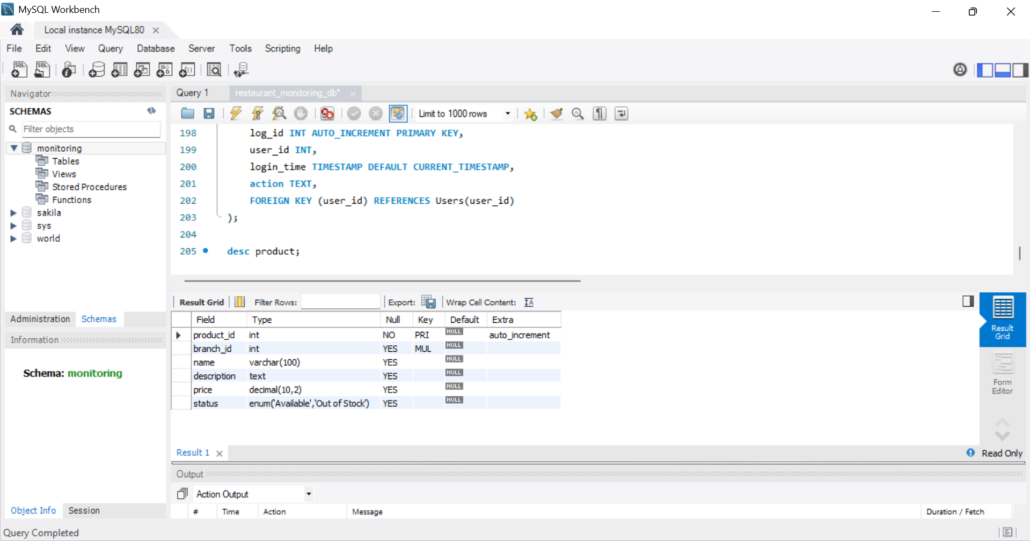

Orders Table Description

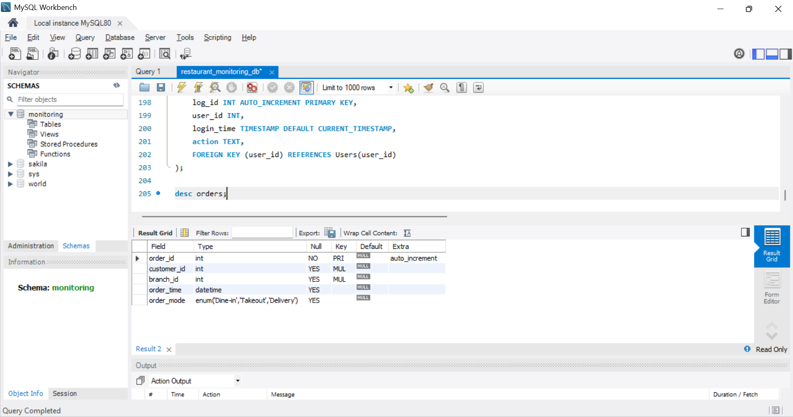

Orders_Item table Description

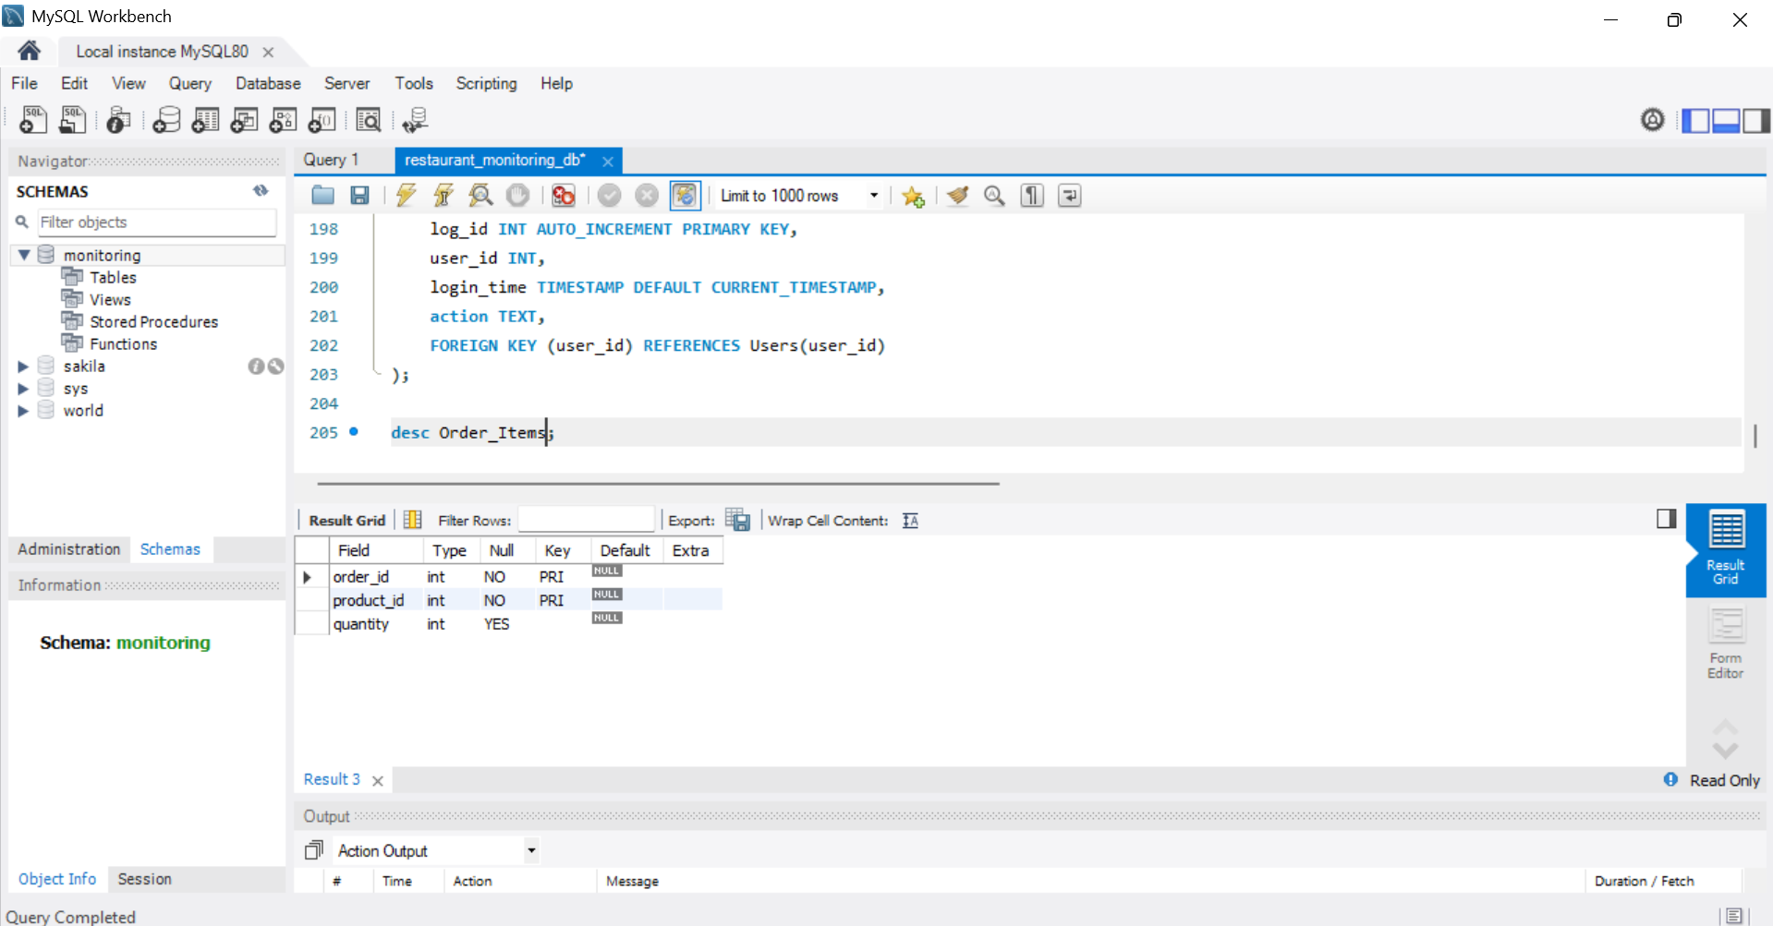

**User Story Description**

|  |  |
| --- | --- |
| **StoryID** | **Story Description** |
| US01 | **As an owner**, I make money from customers so that I can track the revenue generated at each branch. This helps me assess how well my restaurant branches are performing based on customer payments. |
| US02 | **As an owner**, I provide jobs for my employees so that I can assign them roles at specific branches. This enables smooth restaurant operations and clear role responsibilities within each branch. |
| US03 | **As an owner**, I pay taxes to government departments so that my business remains legally compliant. Keeping a record of these payments helps me maintain proper tax documentation and avoid penalties. |
| US04 | **As an owner**, I make payments to suppliers so that I can maintain healthy business relationships and ensure that invoices are settled on time. This allows a continuous supply of goods to manage restaurant inventories efficiently. |
| US05 | **As an owner**, I buy supplies, materials, and equipment from suppliers so that my branches remain well-stocked and operational. These purchases update the inventory system and ensure that all menu items can be prepared without delays. |
| US06 | **As an employee**, I provide labor for my boss (restaurant owner) so that I can fulfill my assigned duties and work as per schedule. This helps the restaurant function smoothly with adequate staff presence at all times. |
| US07 | **As an employee**, I get payroll from my boss (restaurant owner) so that I am compensated for my work. Payroll tracking ensures I receive my salary correctly and on time. |
| US08 | **As a manager**, I want to check the daily sales so that I can monitor the financial performance of my branch. This helps in evaluating our daily targets, planning better, and reporting to the owner. |
| US09 | **As a chef**, I cook food for customers so that they receive the meals they order. I refer to kitchen order details to prepare the right dishes, ensuring customer satisfaction and smooth kitchen operations. |
| US10 | **As a chef helper**, I help chefs with their work in the kitchen so that food preparation is faster and more organized. I assist with tasks like fetching ingredients, cleaning, and basic prep work. |
| US11 | **As a cashier**, I collect money from customers so that I can process their payments and issue receipts. This helps maintain accurate sales records and ensures the branch’s daily revenue is properly tracked. |

**Sprint-2**

**Conceptual Design**

Include your detailed conceptual design here. Use the format shown below.

### ****Entity: Restaurant****

**Attributes:**

* PK* restaurant_id
* name
* branding

### ****Entity: Branch****

**Attributes:**

* PK* branch_id
* FK* restaurant_id
* location
* manager_name
* contact_info
* foreign key (restaurant_id) REFERENCES Restaurant(restaurant_id)

### ****Entity: Employee****

**Attributes:**

* PK* employee_id
* FK* branch_id
* first_name
* last_name
* role
* payroll
* performance_score
* foreign key (branch_id) REFERENCES Branch(branch_id)

### ****Entity: Customer****

**Attributes:**

* PK* customer_id
* name
* phone
* email

### ****Entity: Order****

**Attributes:**

* PK* order_id
* FK* customer_id
* FK* branch_id
* order_time
* order_mode (Dine-in, Takeout, Delivery)
* foreign key (customer_id) REFERENCES Customer(customer_id)
* foreign key (branch_id) REFERENCES Branch(branch_id)

### ****Entity: Product (Menu Item)****

**Attributes:**

* PK* product_id
* FK* branch_id
* name
* description
* price
* status
* foreign key (branch_id) REFERENCES Branch(branch_id)

### ****Entity: Order_Items****

**Attributes:**

* PK* order_item_id
* FK* order_id
* FK* product_id
* quantity
* foreign key (order_id) REFERENCES Order(order_id)
* foreign key (product_id) REFERENCES Product(product_id)

### ****Entity: Payment****

**Attributes:**

* PK* payment_id
* FK* order_id
* amount
* method (Card, Cash, Online)
* payment_time
* foreign key (order_id) REFERENCES Order(order_id)

### ****Entity: Feedback****

**Attributes:**

* PK* feedback_id
* FK* customer_id
* FK* order_id
* rating
* comment
* feedback_date
* foreign key (customer_id) REFERENCES Customer(customer_id)
* foreign key (order_id) REFERENCES Order(order_id)

### ****Entity: Inventory****

**Attributes:**

* PK* inventory_id
* FK* branch_id
* FK* product_id
* stock_level
* threshold
* foreign key (branch_id) REFERENCES Branch(branch_id)
* foreign key (product_id) REFERENCES Product(product_id)

### ****Entity: Supplier****

**Attributes:**

* PK* supplier_id
* name
* contact_info
* category

### ****Entity: Inventory_Supply****

**Attributes:**

* PK* supply_id
* FK* supplier_id
* FK* inventory_id
* invoice_number
* supply_date
* quantity
* foreign key (supplier_id) REFERENCES Supplier(supplier_id)
* foreign key (inventory_id) REFERENCES Inventory(inventory_id)

### ****Entity: Third_Party_Service****

**Attributes:**

* PK* service_id
* FK* branch_id
* service_type
* provider_name
* cost
* service_date
* foreign key (branch_id) REFERENCES Branch(branch_id)

### ****Entity: Government_Agency****

**Attributes:**

* PK* agency_id
* name
* department_type

### ****Entity: Tax_Payment****

**Attributes:**

* PK* tax_payment_id
* FK* branch_id
* FK* agency_id
* amount
* payment_date
* foreign key (branch_id) REFERENCES Branch(branch_id)
* foreign key (agency_id) REFERENCES Government_Agency(agency_id)

### ****Entity: User****

**Attributes:**

* PK* user_id
* username
* password_hash
* role (Admin, Branch_Manager, etc.)

### ****Entity: Report****

**Attributes:**

* PK* report_id
* FK* branch_id
* report_type
* report_date
* data_blob
* foreign key (branch_id) REFERENCES Branch(branch_id)

### ****Entity: Performance_Metrics****

**Attributes:**

* PK* metric_id
* FK* branch_id
* month
* sales_volume
* customer_count
* avg_feedback
* foreign key (branch_id) REFERENCES Branch(branch_id)

### ****Entity: LoginLogs****

**Attributes:**

* PK* log_id
* FK* user_id
* login_time
* logout_time
* ip_address
* foreign key (user_id) REFERENCES User(user_id)

### ****Relationship: Restaurant has Branch****

**Cardinality**: One to Many­­­­­­  
**Participation**:  
Restaurant has total participation  
Branch has total participation

### ****Relationship: Branch has Employee****

**Cardinality**: One to Many  
**Participation**:  
Branch has total participation  
Employee has total participation

### ****Relationship: Branch has Customer****

**Cardinality**: One to Many  
**Participation**:  
Branch has total participation  
Customer has partial participation

### ****Relationship: Customer places Order****

**Cardinality**: One to Many  
**Participation**:  
Customer has partial participation  
Order has total participation

### ****Relationship: Order has Product (via Order_Items)****

**Cardinality**: Many to Many  
**Participation**:  
Order has total participation  
Product has partial participation

### ****Relationship: Branch has Product****

**Cardinality**: One to Many  
**Participation**:  
Branch has total participation  
Product has total participation

### ****Relationship: Branch has Inventory****

**Cardinality**: One to Many  
**Participation**:  
Branch has total participation  
Inventory has total participation

### ****Relationship: Product uses Inventory****

**Cardinality**: Many to Many  
**Participation**:  
Product has partial participation  
Inventory has partial participation

### ****Relationship: Supplier has Inventory****

**Cardinality**: One to Many  
**Participation**:  
Supplier has partial participation  
Inventory has total participation

### ****Relationship: Supplier has Branch****

**Cardinality**: Many to Many  
**Participation**:  
Supplier has partial participation  
Branch has partial participation

### ****Relationship: Customer gives Feedback****

**Cardinality**: One to Many  
**Participation**:  
Customer has partial participation  
Feedback has total participation

### ****Relationship: Feedback refers to Order****

**Cardinality**: Many to One  
**Participation**:  
Feedback has total participation  
Order has partial participation

### ****Relationship: Order has Payment****

**Cardinality**: One to One or One to Many  
**Participation**:  
Order has total participation  
Payment has total participation

### ****Relationship: Branch has Report****

**Cardinality**: One to Many  
**Participation**:  
Branch has total participation  
Report has total participation

### ****Relationship: Branch has Performance Metrics****

**Cardinality**: One to Many  
**Participation**:  
Branch has total participation  
Performance Metrics has total participation

### ****Relationship: Government has Branch****

**Cardinality**: Many to Many  
**Participation**:  
Government has partial participation  
Branch has partial participation

### ****Relationship: Branch has Third Party Service****

**Cardinality**: Many to Many  
**Participation**:  
Branch has partial participation  
Third Party Service has partial participation

### ****Relationship: User has LoginLogs / AuditLogs****

**Cardinality**: One to Many  
**Participation**:  
User has partial participation  
Log has total participation

**LOGICAL DESIGN**

Include your logical design here. Use the format shown below.

### Table: Restaurant

**Columns:**

* PK* restaurant_id
* name
* branding

### Table: Branch

**Columns:**

* PK* branch_id
* FK* restaurant_id
* location
* manager_name
* contact_info

### Table: Employee

**Columns:**

* PK* employee_id
* FK* branch_id
* first_name
* last_name
* role
* payroll
* performance_score

### Table: Customer

**Columns:**

* PK* customer_id
* name
* phone
* email

### Table: Order

**Columns:**

* PK* order_id
* FK* customer_id
* FK* branch_id
* order_time
* order_mode *(Dine-in, Takeout, Delivery)*

### Table: Product (Menu Item)

**Columns:**

* PK* product_id
* FK* branch_id
* name
* description
* price
* status

### Table: Order_Items

**Columns:**

* PK* order_item_id
* FK* order_id
* FK* product_id
* quantity

### Table: Payment

**Columns:**

* PK* payment_id
* FK* order_id
* amount
* method *(Card, Cash, Online)*
* payment_time

### Table: Feedback

**Columns:**

* PK* feedback_id
* FK* customer_id
* FK* order_id
* rating
* comment
* feedback_date

### Table: Inventory

**Columns:**

* PK* inventory_id
* FK* branch_id
* FK* product_id
* stock_level
* threshold

### Table: Supplier

**Columns:**

* PK* supplier_id
* name
* contact_info
* category

### Table: Inventory_Supply

**Columns:**

* PK* supply_id
* FK* supplier_id
* FK* inventory_id
* invoice_number
* supply_date
* quantity

### Table: Third_Party_Service

**Columns:**

* PK* service_id
* FK* branch_id
* service_type
* provider_name
* cost
* service_date

### Table: Government_Agency

**Columns:**

* PK* agency_id
* name
* department_type

### Table: Tax_Payment

**Columns:**

* PK* tax_payment_id
* FK* branch_id
* FK* agency_id
* amount
* payment_date

### Table: User

**Columns:**

* PK* user_id
* username
* password_hash
* role *(Admin, Branch_Manager, etc.)*

### Table: Report

**Columns:**

* PK* report_id
* FK* branch_id
* report_type
* report_date
* data_blob

### Table: Performance_Metrics

**Columns:**

* PK* metric_id
* FK* branch_id
* month
* sales_volume
* customer_count
* avg_feedback

### Table: LoginLogs

**Columns:**

* PK* log_id
* FK* user_id
* login_time
* logout_time
* ip_address

**LOGICAL DESIGN WITH NORMAL FORM IDENTIFICATION**

Include your logical design here. Use the format shown below.

### Table: Restaurant (BCNF)

**Columns**:

* **PK**\* restaurant_id
* name
* branding

### Table: Branch (BCNF)

**Columns**:

* **PK**\* branch_id
* **FK**\* restaurant_id
* location
* manager_name
* contact_info

### Table: Employee (BCNF)

**Columns**:

* **PK**\* employee_id
* **FK**\* branch_id
* first_name
* last_name
* role
* payroll
* performance_score

### Table: Customer (BCNF)

**Columns**:

* **PK**\* customer_id
* name
* phone
* email

### Table: Order (BCNF)

**Columns**:

* **PK**\* order_id
* **FK**\* customer_id
* **FK**\* branch_id
* order_time
* order_mode *(Dine-in, Takeout, Delivery)*

### Table: Product (Menu Item) (BCNF)

**Columns**:

* **PK**\* product_id
* **FK**\* branch_id
* name
* description
* price
* status *(Available / Out of Stock)*

### Table: Order_Items (BCNF)

**Columns**:

* **PK**\* order_item_id
* **FK**\* order_id
* **FK**\* product_id
* quantity

### Table: Payment (BCNF)

**Columns**:

* **PK**\* payment_id
* **FK**\* order_id
* amount
* method *(Card, Cash, Online)*
* payment_time

### Table: Feedback (BCNF)

**Columns**:

* **PK**\* feedback_id
* **FK**\* customer_id
* **FK**\* order_id
* rating
* comment
* feedback_date

### Table: Inventory (BCNF)

**Columns**:

* **PK**\* inventory_id
* **FK**\* branch_id
* **FK**\* product_id
* stock_level
* threshold

### Table: Supplier (BCNF)

**Columns**:

* **PK**\* supplier_id
* name
* contact_info
* category

### Table: Inventory_Supply (BCNF)

**Columns**:

* **PK**\* supply_id
* **FK**\* supplier_id
* **FK**\* inventory_id
* invoice_number
* supply_date
* quantity

### Table: Third_Party_Service (BCNF)

**Columns**:

* **PK**\* service_id
* **FK**\* branch_id
* service_type
* provider_name
* cost
* service_date

### Table: Government_Agency (BCNF)

**Columns**:

* **PK**\* agency_id
* name
* department_type

### Table: Tax_Payment (BCNF)

**Columns**:

* **PK**\* tax_payment_id
* **FK**\* branch_id
* **FK**\* agency_id
* amount
* payment_date

### Table: User (BCNF)

**Columns**:

* **PK**\* user_id
* username
* password_hash
* role *(Admin, Branch_Manager, etc.)*

### Table: Report (BCNF)

**Columns**:

* **PK**\* report_id
* **FK**\* branch_id
* report_type
* report_date
* data_blob

### Table: Performance_Metrics (BCNF)

**Columns**:

* **PK**\* metric_id
* **FK**\* branch_id
* month
* sales_volume
* customer_count
* avg_feedback

### Table: LoginLogs (BCNF)

**Columns**:

* **PK**\* log_id
* **FK**\* user_id
* login_time
* logout_time
* ip_address

**Implementation of Database Schema**

CREATE TABLE Branch (

branch_id INT AUTO_INCREMENT PRIMARY KEY,

restaurant_id INT,

location VARCHAR(255),

manager_name VARCHAR(100),

contact_info VARCHAR(100),

FOREIGN KEY (restaurant_id) REFERENCES Restaurant(restaurant_id)

);

-- Employee Table

CREATE TABLE Employee (

employee_id INT AUTO_INCREMENT PRIMARY KEY,

branch_id INT,

first_name VARCHAR(50),

last_name VARCHAR(50),

role ENUM('Manager', 'Cashier', 'Chef', 'Chef_Helper', 'Waiter/Waitress'),

payroll DECIMAL(10,2),

performance_score DECIMAL(5,2),

FOREIGN KEY (branch_id) REFERENCES Branch(branch_id)

);

-- Customer Table

CREATE TABLE Customer (

customer_id INT AUTO_INCREMENT PRIMARY KEY,

name VARCHAR(100),

phone VARCHAR(15),

email VARCHAR(100)

);

-- Product/Menu Items Table

CREATE TABLE Product (

product_id INT AUTO_INCREMENT PRIMARY KEY,

branch_id INT,

name VARCHAR(100),

description TEXT,

price DECIMAL(10,2),

status ENUM('Available', 'Out of Stock'),

FOREIGN KEY (branch_id) REFERENCES Branch(branch_id)

);

-- Order Table

CREATE TABLE Orders (

order_id INT AUTO_INCREMENT PRIMARY KEY,

customer_id INT,

branch_id INT,

order_time DATETIME,

order_mode ENUM('Dine-in', 'Takeout', 'Delivery'),

FOREIGN KEY (customer_id) REFERENCES Customer(customer_id),

FOREIGN KEY (branch_id) REFERENCES Branch(branch_id)

);

-- Order_Items Table (many-to-many relationship)

CREATE TABLE Order_Items (

order_id INT,

product_id INT,

quantity INT,

PRIMARY KEY(order_id, product_id),

FOREIGN KEY (order_id) REFERENCES Orders(order_id),

FOREIGN KEY (product_id) REFERENCES Product(product_id)

);

-- Payments Table

CREATE TABLE Payments (

payment_id INT AUTO_INCREMENT PRIMARY KEY,

order_id INT,

amount DECIMAL(10,2),

method ENUM('Cash', 'Card', 'Online'),

payment_time DATETIME,

FOREIGN KEY (order_id) REFERENCES Orders(order_id)

);

-- Inventory Table

CREATE TABLE Inventory (

inventory_id INT AUTO_INCREMENT PRIMARY KEY,

branch_id INT,

product_id INT,

quantity_available INT,

threshold_level INT,

FOREIGN KEY (branch_id) REFERENCES Branch(branch_id),

FOREIGN KEY (product_id) REFERENCES Product(product_id)

);

-- Supplier Table

CREATE TABLE Supplier (

supplier_id INT AUTO_INCREMENT PRIMARY KEY,

name VARCHAR(100),

contact_info VARCHAR(100)

);

-- Supplier Inventory Supply Table

CREATE TABLE Supplier_Inventory (

supplier_id INT,

inventory_id INT,

supply_date DATE,

quantity_supplied INT,

invoice_number VARCHAR(50),

PRIMARY KEY (supplier_id, inventory_id),

FOREIGN KEY (supplier_id) REFERENCES Supplier(supplier_id),

FOREIGN KEY (inventory_id) REFERENCES Inventory(inventory_id)

);

-- Feedback Table

CREATE TABLE Feedback (

feedback_id INT AUTO_INCREMENT PRIMARY KEY,

customer_id INT,

order_id INT,

rating INT,

comment TEXT,

feedback_date DATE,

FOREIGN KEY (customer_id) REFERENCES Customer(customer_id),

FOREIGN KEY (order_id) REFERENCES Orders(order_id)

);

-- Government Table

CREATE TABLE Government (

gov_id INT AUTO_INCREMENT PRIMARY KEY,

department_name VARCHAR(100),

contact_info VARCHAR(100)

);

-- Branch Government Transactions

CREATE TABLE Branch_Gov_Transaction (

transaction_id INT AUTO_INCREMENT PRIMARY KEY,

branch_id INT,

gov_id INT,

payment_amount DECIMAL(10,2),

transaction_date DATE,

FOREIGN KEY (branch_id) REFERENCES Branch(branch_id),

FOREIGN KEY (gov_id) REFERENCES Government(gov_id)

);

-- Third Party Services Table

CREATE TABLE ThirdPartyService (

service_id INT AUTO_INCREMENT PRIMARY KEY,

name VARCHAR(100),

service_type VARCHAR(50),

contact_info VARCHAR(100)

);

-- Branch Third Party Service Table

CREATE TABLE Branch_Service (

branch_id INT,

service_id INT,

cost DECIMAL(10,2),

service_date DATE,

PRIMARY KEY (branch_id, service_id),

FOREIGN KEY (branch_id) REFERENCES Branch(branch_id),

FOREIGN KEY (service_id) REFERENCES ThirdPartyService(service_id)

);

-- User/Admin Table

CREATE TABLE Users (

user_id INT AUTO_INCREMENT PRIMARY KEY,

username VARCHAR(50) UNIQUE,

password_hash VARCHAR(255),

role ENUM('Admin', 'Branch_Manager', 'Viewer'),

created_at TIMESTAMP DEFAULT CURRENT_TIMESTAMP

);

-- Reports Table

CREATE TABLE Reports (

report_id INT AUTO_INCREMENT PRIMARY KEY,

branch_id INT,

report_type ENUM('Sales', 'Inventory', 'Performance'),

report_date DATE,

content TEXT,

FOREIGN KEY (branch_id) REFERENCES Branch(branch_id)

);

-- Performance Metrics Table

CREATE TABLE PerformanceMetrics (

metric_id INT AUTO_INCREMENT PRIMARY KEY,

branch_id INT,

month_year VARCHAR(7), -- Format 'YYYY-MM'

sales_volume DECIMAL(10,2),

customer_count INT,

avg_feedback_score DECIMAL(4,2),

FOREIGN KEY (branch_id) REFERENCES Branch(branch_id)

);

-- Login Logs Table

CREATE TABLE LoginLogs (

log_id INT AUTO_INCREMENT PRIMARY KEY,

user_id INT,

login_time TIMESTAMP DEFAULT CURRENT_TIMESTAMP,

action TEXT,

FOREIGN KEY (user_id) REFERENCES Users(user_id));

**Implementation Data**

-- 1. Restaurants

INSERT INTO Restaurant (name, branding) VALUES

('Spicy Rasoi', 'Authentic Indian Veg Cuisine'),

('Biryani Bhavan', 'Hyderabadi Dum Biryani Specialists'),

('Tandoori Trails', 'North Indian Grilled Delights');

-- 2. Branches

INSERT INTO Branch (restaurant_id, location, manager_name, contact_info) VALUES

(1, 'Banjara Hills, Hyderabad', 'Ramesh Iyer', '040-6789012'),

(1, 'T. Nagar, Chennai', 'Meera Subramaniam', '044-2388123'),

(2, 'Gachibowli, Hyderabad', 'Syed Akbar', '040-2221100'),

(2, 'Indiranagar, Bengaluru', 'Nisha Reddy', '080-5544332'),

(3, 'Connaught Place, Delhi', 'Raj Malhotra', '011-9988776');

-- 3. Employees

INSERT INTO Employee (branch_id, first_name, last_name, role, payroll, performance_score) VALUES

(1, 'Anita', 'Sharma', 'Manager', 55000.00, 9.2),

(1, 'Manoj', 'Kumar', 'Chef', 32000.00, 8.5),

(2, 'Priya', 'Rao', 'Cashier', 25000.00, 8.9),

(3, 'Ahmed', 'Khan', 'Manager', 58000.00, 9.0),

(4, 'Ravi', 'Shankar', 'Chef', 30000.00, 8.0),

(4, 'Geeta', 'Mishra', 'Waiter/Waitress', 18000.00, 7.5),

(5, 'Kunal', 'Verma', 'Manager', 60000.00, 9.1),

(5, 'Deepa', 'Joshi', 'Chef_Helper', 16000.00, 7.8);

-- 4. Customers

INSERT INTO Customer (name, phone, email) VALUES

('Rahul Mehta', '9876543210', 'rahul@example.com'),

('Sneha Agarwal', '9123456789', 'sneha@example.com'),

('Vikram Desai', '9345678912', 'vikram@example.com');

-- 5. Products

INSERT INTO Product (branch_id, name, description, price, status) VALUES

(1, 'Paneer Butter Masala', 'Creamy cottage cheese curry', 250.00, 'Available'),

(2, 'Masala Dosa', 'Crispy dosa with spicy potato filling', 120.00, 'Available'),

(3, 'Hyderabadi Chicken Biryani', 'Traditional dum biryani', 300.00, 'Available'),

(4, 'Veg Thali', 'Assorted veg dishes with roti and rice', 200.00, 'Available'),

(5, 'Tandoori Chicken', 'Spicy grilled chicken', 280.00, 'Available');

-- 6. Orders

INSERT INTO Orders (customer_id, branch_id, order_time, order_mode) VALUES

(1, 1, '2025-04-20 13:00:00', 'Dine-in'),

(2, 3, '2025-04-20 14:00:00', 'Takeout'),

(3, 5, '2025-04-20 19:30:00', 'Delivery');

-- 7. Order_Items

INSERT INTO Order_Items (order_id, product_id, quantity) VALUES

(1, 1, 2),

(2, 3, 1),

(3, 5, 2);

-- 8. Payments

INSERT INTO Payments (order_id, amount, method, payment_time) VALUES

(1, 500.00, 'Card', '2025-04-20 13:15:00'),

(2, 300.00, 'Cash', '2025-04-20 14:05:00'),

(3, 560.00, 'Online', '2025-04-20 19:45:00');

-- 9. Feedback

INSERT INTO Feedback (customer_id, order_id, rating, comment, feedback_date) VALUES

(1, 1, 5, 'Delicious and authentic taste!', '2025-04-20'),

(2, 2, 4, 'Good biryani, could be spicier.', '2025-04-20'),

(3, 3, 5, 'Excellent delivery and taste!', '2025-04-20');

-- 10. Inventory

INSERT INTO Inventory (branch_id, product_id, quantity_available, threshold_level) VALUES

(1, 1, 100, 20),

(2, 2, 150, 30),

(3, 3, 200, 25),

(4, 4, 80, 15),

(5, 5, 120, 25);

-- 11. Supplier

INSERT INTO Supplier (name, contact_info) VALUES

('Fresh Farms India', '040-4445556'),

('Spice World Traders', '080-3344556');

-- 12. Supplier_Inventory

INSERT INTO Supplier_Inventory (supplier_id, inventory_id, supply_date, quantity_supplied, invoice_number) VALUES

(1, 1, '2025-04-19', 50, 'INV001'),

(2, 2, '2025-04-19', 60, 'INV002');

-- 13. Government

INSERT INTO Government (department_name, contact_info) VALUES

('GST Department', 'gst@gov.in'),

('Food Safety Authority', 'foodsafety@gov.in');

-- 14. Branch_Gov_Transaction

INSERT INTO Branch_Gov_Transaction (branch_id, gov_id, payment_amount, transaction_date) VALUES

(1, 1, 10000.00, '2025-04-01'),

(3, 2, 5000.00, '2025-04-02');

-- 15. ThirdPartyService

INSERT INTO ThirdPartyService (name, service_type, contact_info) VALUES

('BBMP Water Supply', 'Utility', 'bbmp@services.in'),

('KitchenFix Pvt Ltd', 'Maintenance', 'support@kitchenfix.in');

-- 16. Branch_Service

INSERT INTO Branch_Service (branch_id, service_id, cost, service_date) VALUES

(2, 1, 2000.00, '2025-04-15'),

(4, 2, 3500.00, '2025-04-18');

-- 17. Users

INSERT INTO Users (username, password_hash, role) VALUES

('admin1', 'hash_admin', 'Admin'),

('manager_hyd', 'hash_mngr1', 'Branch_Manager'),

('manager_delhi', 'hash_mngr2', 'Branch_Manager');

-- 18. Reports

INSERT INTO Reports (branch_id, report_type, report_date, content) VALUES

(1, 'Sales', '2025-04-20', 'Total sales: ₹50000'),

(3, 'Inventory', '2025-04-19', 'Restocked 60 biryanis');

-- 19. PerformanceMetrics

INSERT INTO PerformanceMetrics (branch_id, month_year, sales_volume, customer_count, avg_feedback_score) VALUES

(1, '2025-04', 120000.00, 500, 4.7),

(3, '2025-04', 95000.00, 420, 4.4);

-- 20. LoginLogs

INSERT INTO LoginLogs (user_id, action) VALUES

(1, 'Logged in as Admin'),

(2, 'Viewed Sales Report');

**User Story Refinement**

|  |  |
| --- | --- |
| **Story ID** | **User Story** |
| US01 | As an **owner**, I want to track revenue from each branch so that I can assess branch performance based on customer payments. |
| US02 | As an **owner**, I want to assign roles to employees in specific branches so that operations run smoothly with clear responsibilities. |
| US03 | As an **owner**, I want to record tax payments to government departments so that my business remains legally compliant and avoids penalties. |
| US04 | As an **owner**, I want to make timely payments to suppliers so that I can maintain healthy business relationships and ensure continuous inventory supply. |
| US05 | As an **owner**, I want to purchase supplies and update the inventory system so that branches remain well-stocked and menu items can be prepared without delays. |
| US06 | As an **employee**, I want to follow my assigned duties and schedule so that the restaurant operates smoothly with adequate staffing. |
| US07 | As an **employee**, I want to receive accurate and timely payroll so that I am compensated correctly for my work. |
| US08 | As a **manager**, I want to monitor daily sales so that I can evaluate financial performance, set targets, and report to the owner. |
| US09 | As a **chef**, I want to cook and refer to kitchen orders so that I can ensure customer satisfaction and smooth kitchen operations. |
| US10 | As a **chef helper**, I want to assist with kitchen tasks so that food preparation is faster and more organized. |
| US11 | As a **cashier**, I want to collect payments and issue receipts so that sales records are accurate and daily revenue is tracked properly. |

**SQL QUERIES**

Modify your database to reflect all changes made in this sprint.

In other words:

● Create (or update) new (or existing) tables according to your updated, normalized logical design.

● In all tables (old and new): ○ ensure that appropriate data types are chosen for all columns; ○ identify and set up any NOT NULL and UNIQUE constraints; ○ set up its primary key; ○ set up all foreign keys.

● Populate your tables with relevant, meaningful data, updating old data as needed. Note: Do not attempt to manually update your Sprint 1 database. Instead,

● export your Sprint 1 schema as a SQL script;

● make updates to the script to reflect the updated tables/data;

● create a new Sprint 2 schema;

● import your updated script into this new Sprint 2 schema.

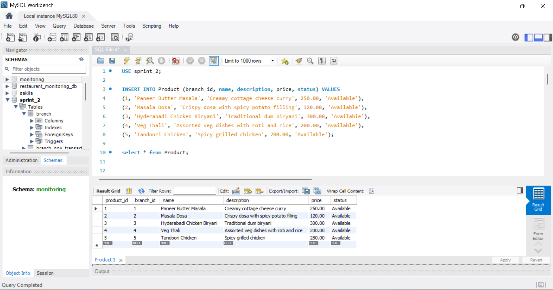

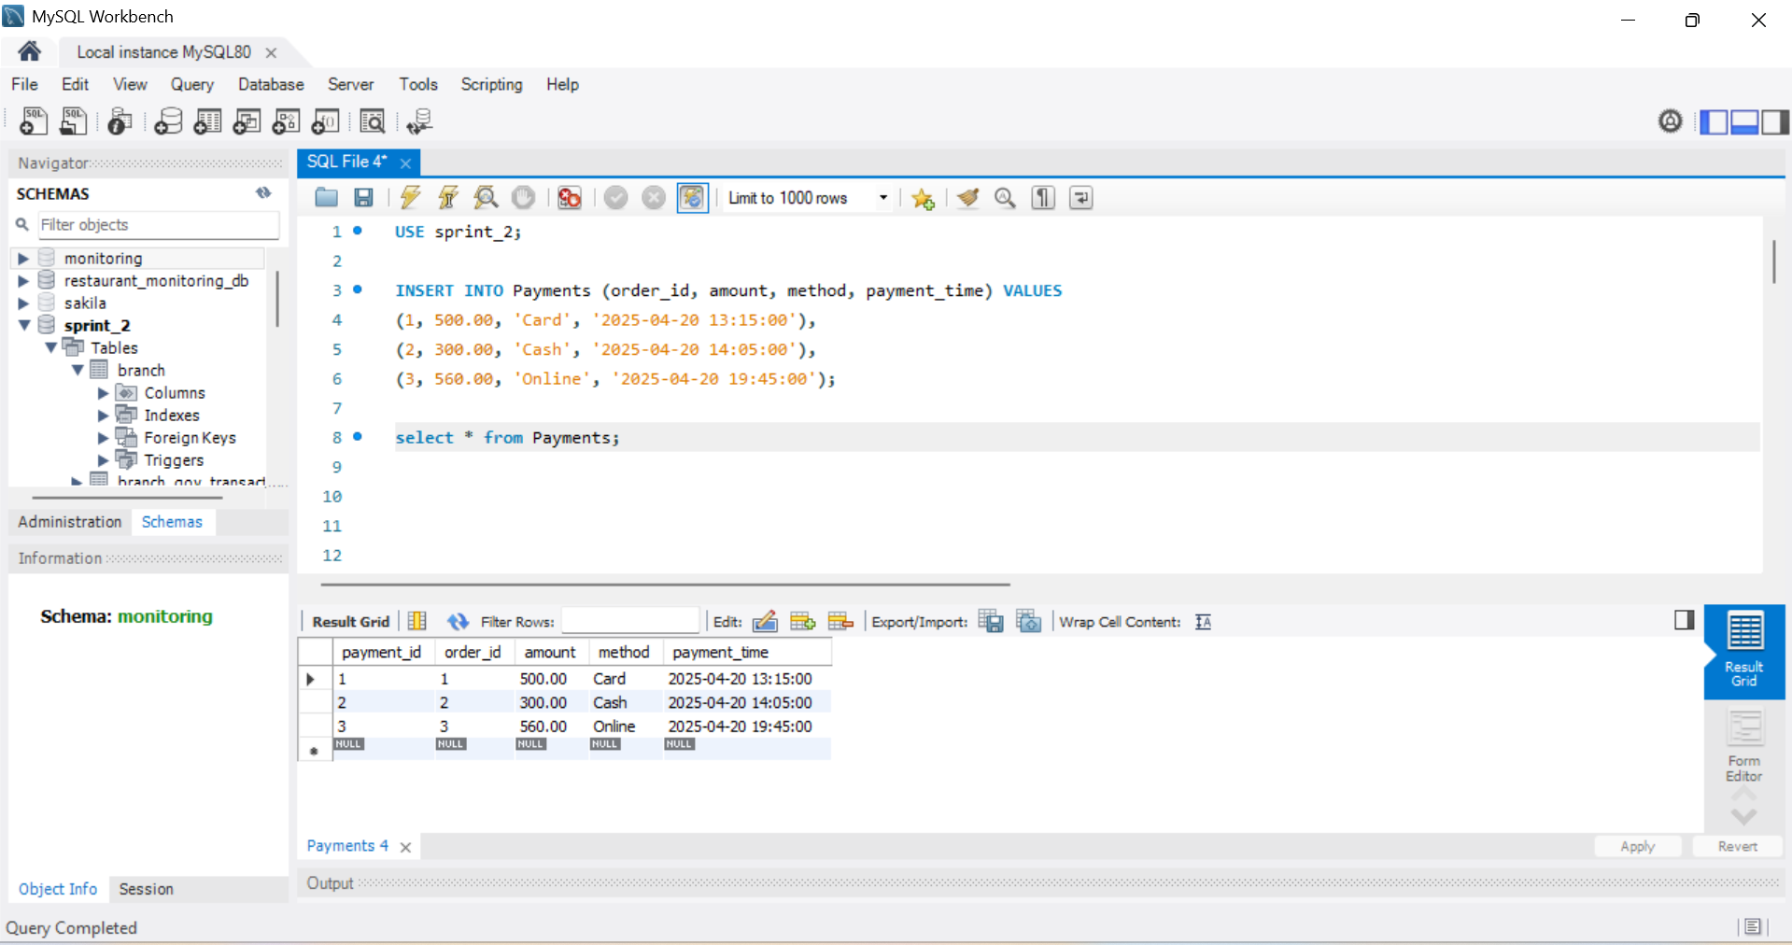

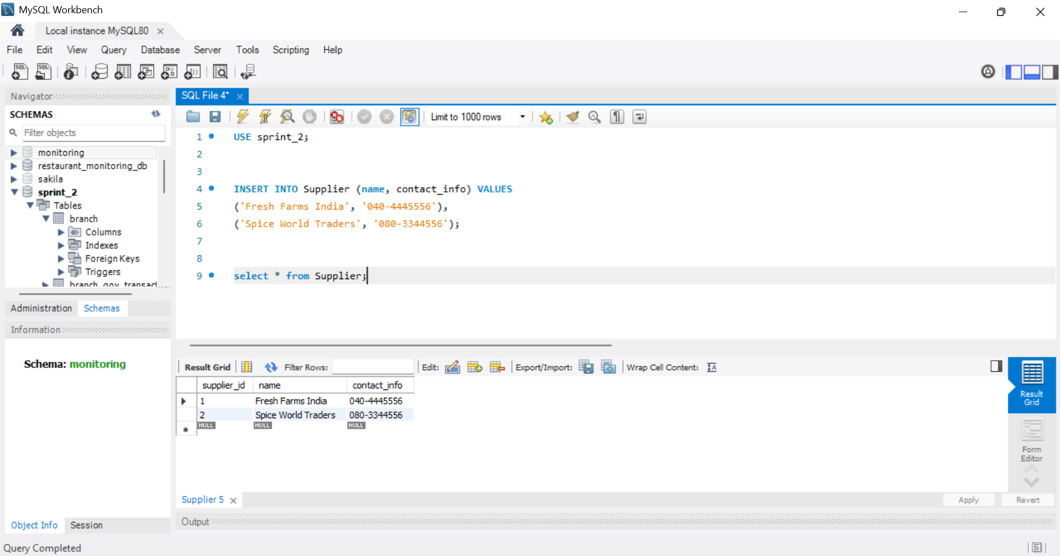

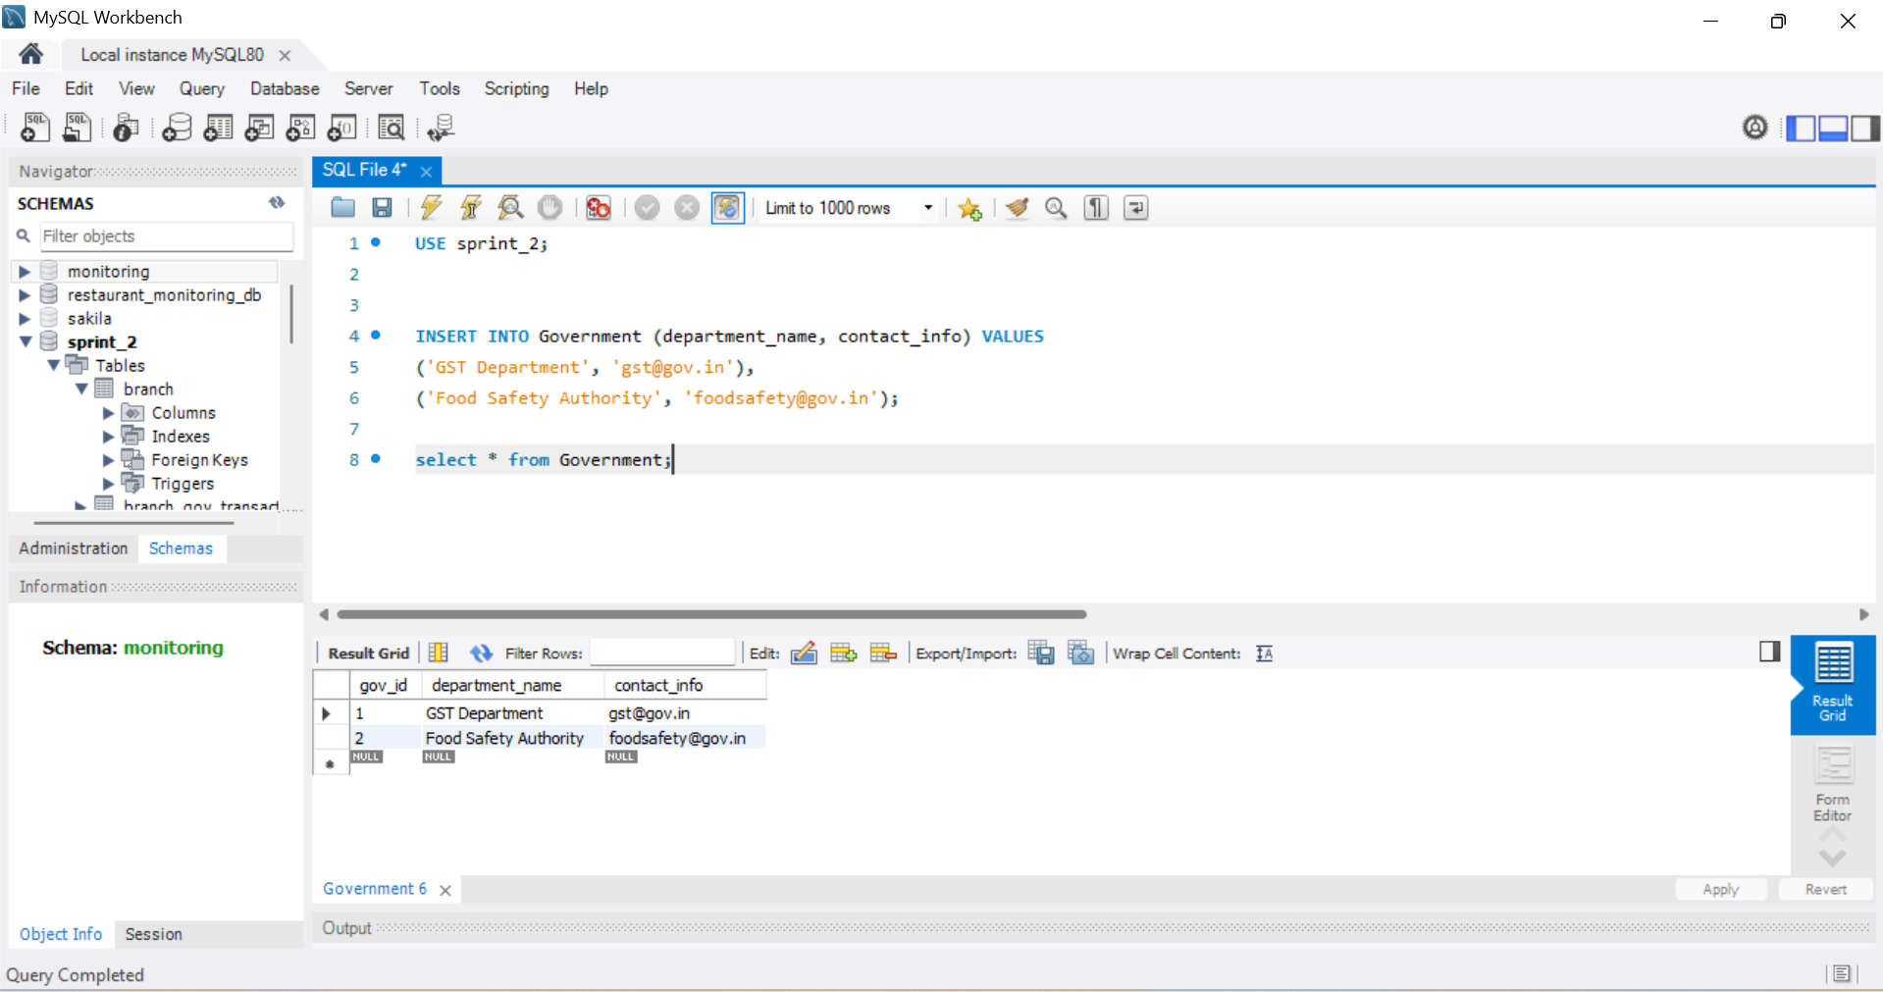

**Sprint-3**

**User Story Description**

|  |  |
| --- | --- |
| **StoryID** | **Story Description** |
| US01 | **As an owner**, I make money from customers so that I can track the revenue generated at each branch. This helps me assess how well my restaurant branches are performing based on customer payments. |
| US02 | **As an owner**, I provide jobs for my employees so that I can assign them roles at specific branches. This enables smooth restaurant operations and clear role responsibilities within each branch. |
| US03 | **As an owner**, I pay taxes to government departments so that my business remains legally compliant. Keeping a record of these payments helps me maintain proper tax documentation and avoid penalties. |
| US04 | **As an owner**, I make payments to suppliers so that I can maintain healthy business relationships and ensure that invoices are settled on time. This allows a continuous supply of goods to manage restaurant inventories efficiently. |
| US05 | **As an owner**, I buy supplies, materials, and equipment from suppliers so that my branches remain well-stocked and operational. These purchases update the inventory system and ensure that all menu items can be prepared without delays. |
| US06 | **As an employee**, I provide labor for my boss (restaurant owner) so that I can fulfill my assigned duties and work as per schedule. This helps the restaurant function smoothly with adequate staff presence at all times. |
| US07 | **As an employee**, I get payroll from my boss (restaurant owner) so that I am compensated for my work. Payroll tracking ensures I receive my salary correctly and on time. |
| US08 | **As a manager**, I want to check the daily sales so that I can monitor the financial performance of my branch. This helps in evaluating our daily targets, planning better, and reporting to the owner. |
| US09 | **As a chef**, I cook food for customers so that they receive the meals they order. I refer to kitchen order details to prepare the right dishes, ensuring customer satisfaction and smooth kitchen operations. |
| US10 | **As a chef helper**, I help chefs with their work in the kitchen so that food preparation is faster and more organized. I assist with tasks like fetching ingredients, cleaning, and basic prep work. |
| US11 | **As a cashier**, I collect money from customers so that I can process their payments and issue receipts. This helps maintain accurate sales records and ensures the branch’s daily revenue is properly tracked. |

**Conceptual Design**

Include your detailed conceptual design here. Use the format shown below.

### ****Entity: Restaurant****

**Attributes:**

* PK* restaurant_id
* name
* branding

### ****Entity: Branch****

**Attributes:**

* PK* branch_id
* FK* restaurant_id
* location
* manager_name
* contact_info
* foreign key (restaurant_id) REFERENCES Restaurant(restaurant_id)

### ****Entity: Employee****

**Attributes:**

* PK* employee_id
* FK* branch_id
* first_name
* last_name
* role
* payroll
* performance_score
* foreign key (branch_id) REFERENCES Branch(branch_id)

### ****Entity: Customer****

**Attributes:**

* PK* customer_id
* name
* phone
* email

### ****Entity: Order****

**Attributes:**

* PK* order_id
* FK* customer_id
* FK* branch_id
* order_time
* order_mode (Dine-in, Takeout, Delivery)
* foreign key (customer_id) REFERENCES Customer(customer_id)
* foreign key (branch_id) REFERENCES Branch(branch_id)

### ****Entity: Product (Menu Item)****

**Attributes:**

* PK* product_id
* FK* branch_id
* name
* description
* price
* status
* foreign key (branch_id) REFERENCES Branch(branch_id)

### ****Entity: Order_Items****

**Attributes:**

* PK* order_item_id
* FK* order_id
* FK* product_id
* quantity
* foreign key (order_id) REFERENCES Order(order_id)
* foreign key (product_id) REFERENCES Product(product_id)

### ****Entity: Payment****

**Attributes:**

* PK* payment_id
* FK* order_id
* amount
* method (Card, Cash, Online)
* payment_time
* foreign key (order_id) REFERENCES Order(order_id)

### ****Entity: Feedback****

**Attributes:**

* PK* feedback_id
* FK* customer_id
* FK* order_id
* rating
* comment
* feedback_date
* foreign key (customer_id) REFERENCES Customer(customer_id)
* foreign key (order_id) REFERENCES Order(order_id)

### ****Entity: Inventory****

**Attributes:**

* PK* inventory_id
* FK* branch_id
* FK* product_id
* stock_level
* threshold
* foreign key (branch_id) REFERENCES Branch(branch_id)
* foreign key (product_id) REFERENCES Product(product_id)

### ****Entity: Supplier****

**Attributes:**

* PK* supplier_id
* name
* contact_info
* category

### ****Entity: Inventory_Supply****

**Attributes:**

* PK* supply_id
* FK* supplier_id
* FK* inventory_id
* invoice_number
* supply_date
* quantity
* foreign key (supplier_id) REFERENCES Supplier(supplier_id)
* foreign key (inventory_id) REFERENCES Inventory(inventory_id)

### ****Entity: Third_Party_Service****

**Attributes:**

* PK* service_id
* FK* branch_id
* service_type
* provider_name
* cost
* service_date
* foreign key (branch_id) REFERENCES Branch(branch_id)

### ****Entity: Government_Agency****

**Attributes:**

* PK* agency_id
* name
* department_type

### ****Entity: Tax_Payment****

**Attributes:**

* PK* tax_payment_id
* FK* branch_id
* FK* agency_id
* amount
* payment_date
* foreign key (branch_id) REFERENCES Branch(branch_id)
* foreign key (agency_id) REFERENCES Government_Agency(agency_id)

### ****Entity: User****

**Attributes:**

* PK* user_id
* username
* password_hash
* role (Admin, Branch_Manager, etc.)

### ****Entity: Report****

**Attributes:**

* PK* report_id
* FK* branch_id
* report_type
* report_date
* data_blob
* foreign key (branch_id) REFERENCES Branch(branch_id)

### ****Entity: Performance_Metrics****

**Attributes:**

* PK* metric_id
* FK* branch_id
* month
* sales_volume
* customer_count
* avg_feedback
* foreign key (branch_id) REFERENCES Branch(branch_id)

### ****Entity: LoginLogs****

**Attributes:**

* PK* log_id
* FK* user_id
* login_time
* logout_time
* ip_address
* foreign key (user_id) REFERENCES User(user_id)

### ****Relationship: Restaurant has Branch****

**Cardinality**: One to Many­­­­­­  
**Participation**:  
Restaurant has total participation  
Branch has total participation

### ****Relationship: Branch has Employee****

**Cardinality**: One to Many  
**Participation**:  
Branch has total participation  
Employee has total participation

### ****Relationship: Branch has Customer****

**Cardinality**: One to Many  
**Participation**:  
Branch has total participation  
Customer has partial participation

### ****Relationship: Customer places Order****

**Cardinality**: One to Many  
**Participation**:  
Customer has partial participation  
Order has total participation

### ****Relationship: Order has Product (via Order_Items)****

**Cardinality**: Many to Many  
**Participation**:  
Order has total participation  
Product has partial participation

### ****Relationship: Branch has Product****

**Cardinality**: One to Many  
**Participation**:  
Branch has total participation  
Product has total participation

### ****Relationship: Branch has Inventory****

**Cardinality**: One to Many  
**Participation**:  
Branch has total participation  
Inventory has total participation

### ****Relationship: Product uses Inventory****

**Cardinality**: Many to Many  
**Participation**:  
Product has partial participation  
Inventory has partial participation

### ****Relationship: Supplier has Inventory****

**Cardinality**: One to Many  
**Participation**:  
Supplier has partial participation  
Inventory has total participation

### ****Relationship: Supplier has Branch****

**Cardinality**: Many to Many  
**Participation**:  
Supplier has partial participation  
Branch has partial participation

### ****Relationship: Customer gives Feedback****

**Cardinality**: One to Many  
**Participation**:  
Customer has partial participation  
Feedback has total participation

### ****Relationship: Feedback refers to Order****

**Cardinality**: Many to One  
**Participation**:  
Feedback has total participation  
Order has partial participation

### ****Relationship: Order has Payment****

**Cardinality**: One to One or One to Many  
**Participation**:  
Order has total participation  
Payment has total participation

### ****Relationship: Branch has Report****

**Cardinality**: One to Many  
**Participation**:  
Branch has total participation  
Report has total participation

### ****Relationship: Branch has Performance Metrics****

**Cardinality**: One to Many  
**Participation**:  
Branch has total participation  
Performance Metrics has total participation

### ****Relationship: Government has Branch****

**Cardinality**: Many to Many  
**Participation**:  
Government has partial participation  
Branch has partial participation

### ****Relationship: Branch has Third Party Service****

**Cardinality**: Many to Many  
**Participation**:  
Branch has partial participation  
Third Party Service has partial participation

### ****Relationship: User has LoginLogs / AuditLogs****

**Cardinality**: One to Many  
**Participation**:  
User has partial participation  
Log has total participation

**LOGICAL DESIGN**

Include your logical design here. Use the format shown below.

### Table: Restaurant

**Columns:**

* PK* restaurant_id
* name
* branding

### Table: Branch

**Columns:**

* PK* branch_id
* FK* restaurant_id
* location
* manager_name
* contact_info

### Table: Employee

**Columns:**

* PK* employee_id
* FK* branch_id
* first_name
* last_name
* role
* payroll
* performance_score

### Table: Customer

**Columns:**

* PK* customer_id
* name
* phone
* email

### Table: Order

**Columns:**

* PK* order_id
* FK* customer_id
* FK* branch_id
* order_time
* order_mode *(Dine-in, Takeout, Delivery)*

### Table: Product (Menu Item)

**Columns:**

* PK* product_id
* FK* branch_id
* name
* description
* price
* status

### Table: Order_Items

**Columns:**

* PK* order_item_id
* FK* order_id
* FK* product_id
* quantity

### Table: Payment

**Columns:**

* PK* payment_id
* FK* order_id
* amount
* method *(Card, Cash, Online)*
* payment_time

### Table: Feedback

**Columns:**

* PK* feedback_id
* FK* customer_id
* FK* order_id
* rating
* comment
* feedback_date

### Table: Inventory

**Columns:**

* PK* inventory_id
* FK* branch_id
* FK* product_id
* stock_level
* threshold

### Table: Supplier

**Columns:**

* PK* supplier_id
* name
* contact_info
* category

### Table: Inventory_Supply

**Columns:**

* PK* supply_id
* FK* supplier_id
* FK* inventory_id
* invoice_number
* supply_date
* quantity

### Table: Third_Party_Service

**Columns:**

* PK* service_id
* FK* branch_id
* service_type
* provider_name
* cost
* service_date

### Table: Government_Agency

**Columns:**

* PK* agency_id
* name
* department_type

### Table: Tax_Payment

**Columns:**

* PK* tax_payment_id
* FK* branch_id
* FK* agency_id
* amount
* payment_date

### Table: User

**Columns:**

* PK* user_id
* username
* password_hash
* role *(Admin, Branch_Manager, etc.)*

### Table: Report

**Columns:**

* PK* report_id
* FK* branch_id
* report_type
* report_date
* data_blob

### Table: Performance_Metrics

**Columns:**

* PK* metric_id
* FK* branch_id
* month
* sales_volume
* customer_count
* avg_feedback

### Table: LoginLogs

**Columns:**

* PK* log_id
* FK* user_id
* login_time
* logout_time

ip_address

**LOGICAL DESIGN WITH NORMAL FORM IDENTIFICATION**

Include your logical design here. Use the format shown below.

### Table: Restaurant (BCNF)

**Columns**:

* **PK**\* restaurant_id
* name
* branding

### Table: Branch (BCNF)

**Columns**:

* **PK**\* branch_id
* **FK**\* restaurant_id
* location
* manager_name
* contact_info

### Table: Employee (BCNF)

**Columns**:

* **PK**\* employee_id
* **FK**\* branch_id
* first_name
* last_name
* role
* payroll
* performance_score

### Table: Customer (BCNF)

**Columns**:

* **PK**\* customer_id
* name
* phone
* email

### Table: Order (BCNF)

**Columns**:

* **PK**\* order_id
* **FK**\* customer_id
* **FK**\* branch_id
* order_time
* order_mode *(Dine-in, Takeout, Delivery)*

### Table: Product (Menu Item) (BCNF)

**Columns**:

* **PK**\* product_id
* **FK**\* branch_id
* name
* description
* price
* status *(Available / Out of Stock)*

### Table: Order_Items (BCNF)

**Columns**:

* **PK**\* order_item_id
* **FK**\* order_id
* **FK**\* product_id
* quantity

### Table: Payment (BCNF)

**Columns**:

* **PK**\* payment_id
* **FK**\* order_id
* amount
* method *(Card, Cash, Online)*
* payment_time

### Table: Feedback (BCNF)

**Columns**:

* **PK**\* feedback_id
* **FK**\* customer_id
* **FK**\* order_id
* rating
* comment
* feedback_date

### Table: Inventory (BCNF)

**Columns**:

* **PK**\* inventory_id
* **FK**\* branch_id
* **FK**\* product_id
* stock_level
* threshold

### Table: Supplier (BCNF)

**Columns**:

* **PK**\* supplier_id
* name
* contact_info
* category

### Table: Inventory_Supply (BCNF)

**Columns**:

* **PK**\* supply_id
* **FK**\* supplier_id
* **FK**\* inventory_id
* invoice_number
* supply_date
* quantity

### Table: Third_Party_Service (BCNF)

**Columns**:

* **PK**\* service_id
* **FK**\* branch_id
* service_type
* provider_name
* cost
* service_date

### Table: Government_Agency (BCNF)

**Columns**:

* **PK**\* agency_id
* name
* department_type

### Table: Tax_Payment (BCNF)

**Columns**:

* **PK**\* tax_payment_id
* **FK**\* branch_id
* **FK**\* agency_id
* amount
* payment_date

### Table: User (BCNF)

**Columns**:

* **PK**\* user_id
* username
* password_hash
* role *(Admin, Branch_Manager, etc.)*

### Table: Report (BCNF)

**Columns**:

* **PK**\* report_id
* **FK**\* branch_id
* report_type
* report_date
* data_blob

### Table: Performance_Metrics (BCNF)

**Columns**:

* **PK**\* metric_id
* **FK**\* branch_id
* month
* sales_volume
* customer_count
* avg_feedback

### Table: LoginLogs (BCNF)

**Columns**:

* **PK**\* log_id
* **FK**\* user_id
* login_time
* logout_time
* ip_address

**Implementation of Database Schema**

CREATE TABLE Branch (

branch_id INT AUTO_INCREMENT PRIMARY KEY,

restaurant_id INT,

location VARCHAR(255),

manager_name VARCHAR(100),

contact_info VARCHAR(100),

FOREIGN KEY (restaurant_id) REFERENCES Restaurant(restaurant_id)

);

-- Employee Table

CREATE TABLE Employee (

employee_id INT AUTO_INCREMENT PRIMARY KEY,

branch_id INT,

first_name VARCHAR(50),

last_name VARCHAR(50),

role ENUM('Manager', 'Cashier', 'Chef', 'Chef_Helper', 'Waiter/Waitress'),

payroll DECIMAL(10,2),

performance_score DECIMAL(5,2),

FOREIGN KEY (branch_id) REFERENCES Branch(branch_id)

);

-- Customer Table

CREATE TABLE Customer (

customer_id INT AUTO_INCREMENT PRIMARY KEY,

name VARCHAR(100),

phone VARCHAR(15),

email VARCHAR(100)

);

-- Product/Menu Items Table

CREATE TABLE Product (

product_id INT AUTO_INCREMENT PRIMARY KEY,

branch_id INT,

name VARCHAR(100),

description TEXT,

price DECIMAL(10,2),

status ENUM('Available', 'Out of Stock'),

FOREIGN KEY (branch_id) REFERENCES Branch(branch_id)

);

-- Order Table

CREATE TABLE Orders (

order_id INT AUTO_INCREMENT PRIMARY KEY,

customer_id INT,

branch_id INT,

order_time DATETIME,

order_mode ENUM('Dine-in', 'Takeout', 'Delivery'),

FOREIGN KEY (customer_id) REFERENCES Customer(customer_id),

FOREIGN KEY (branch_id) REFERENCES Branch(branch_id)

);

-- Order_Items Table (many-to-many relationship)

CREATE TABLE Order_Items (

order_id INT,

product_id INT,

quantity INT,

PRIMARY KEY(order_id, product_id),

FOREIGN KEY (order_id) REFERENCES Orders(order_id),

FOREIGN KEY (product_id) REFERENCES Product(product_id)

);

-- Payments Table

CREATE TABLE Payments (

payment_id INT AUTO_INCREMENT PRIMARY KEY,

order_id INT,

amount DECIMAL(10,2),

method ENUM('Cash', 'Card', 'Online'),

payment_time DATETIME,

FOREIGN KEY (order_id) REFERENCES Orders(order_id)

);

-- Inventory Table

CREATE TABLE Inventory (

inventory_id INT AUTO_INCREMENT PRIMARY KEY,

branch_id INT,

product_id INT,

quantity_available INT,

threshold_level INT,

FOREIGN KEY (branch_id) REFERENCES Branch(branch_id),

FOREIGN KEY (product_id) REFERENCES Product(product_id)

);

-- Supplier Table

CREATE TABLE Supplier (

supplier_id INT AUTO_INCREMENT PRIMARY KEY,

name VARCHAR(100),

contact_info VARCHAR(100)

);

-- Supplier Inventory Supply Table

CREATE TABLE Supplier_Inventory (

supplier_id INT,

inventory_id INT,

supply_date DATE,

quantity_supplied INT,

invoice_number VARCHAR(50),

PRIMARY KEY (supplier_id, inventory_id),

FOREIGN KEY (supplier_id) REFERENCES Supplier(supplier_id),

FOREIGN KEY (inventory_id) REFERENCES Inventory(inventory_id)

);

-- Feedback Table

CREATE TABLE Feedback (

feedback_id INT AUTO_INCREMENT PRIMARY KEY,

customer_id INT,

order_id INT,

rating INT,

comment TEXT,

feedback_date DATE,

FOREIGN KEY (customer_id) REFERENCES Customer(customer_id),

FOREIGN KEY (order_id) REFERENCES Orders(order_id)

);

-- Government Table

CREATE TABLE Government (

gov_id INT AUTO_INCREMENT PRIMARY KEY,

department_name VARCHAR(100),

contact_info VARCHAR(100)

);

-- Branch Government Transactions

CREATE TABLE Branch_Gov_Transaction (

transaction_id INT AUTO_INCREMENT PRIMARY KEY,

branch_id INT,

gov_id INT,

payment_amount DECIMAL(10,2),

transaction_date DATE,

FOREIGN KEY (branch_id) REFERENCES Branch(branch_id),

FOREIGN KEY (gov_id) REFERENCES Government(gov_id)

);

-- Third Party Services Table

CREATE TABLE ThirdPartyService (

service_id INT AUTO_INCREMENT PRIMARY KEY,

name VARCHAR(100),

service_type VARCHAR(50),

contact_info VARCHAR(100)

);

-- Branch Third Party Service Table

CREATE TABLE Branch_Service (

branch_id INT,

service_id INT,

cost DECIMAL(10,2),

service_date DATE,

PRIMARY KEY (branch_id, service_id),

FOREIGN KEY (branch_id) REFERENCES Branch(branch_id),

FOREIGN KEY (service_id) REFERENCES ThirdPartyService(service_id)

);

-- User/Admin Table

CREATE TABLE Users (

user_id INT AUTO_INCREMENT PRIMARY KEY,

username VARCHAR(50) UNIQUE,

password_hash VARCHAR(255),

role ENUM('Admin', 'Branch_Manager', 'Viewer'),

created_at TIMESTAMP DEFAULT CURRENT_TIMESTAMP

);

-- Reports Table

CREATE TABLE Reports (

report_id INT AUTO_INCREMENT PRIMARY KEY,

branch_id INT,

report_type ENUM('Sales', 'Inventory', 'Performance'),

report_date DATE,

content TEXT,

FOREIGN KEY (branch_id) REFERENCES Branch(branch_id)

);

-- Performance Metrics Table

CREATE TABLE PerformanceMetrics (

metric_id INT AUTO_INCREMENT PRIMARY KEY,

branch_id INT,

month_year VARCHAR(7), -- Format 'YYYY-MM'

sales_volume DECIMAL(10,2),

customer_count INT,

avg_feedback_score DECIMAL(4,2),

FOREIGN KEY (branch_id) REFERENCES Branch(branch_id)

);

-- Login Logs Table

CREATE TABLE LoginLogs (

log_id INT AUTO_INCREMENT PRIMARY KEY,

user_id INT,

login_time TIMESTAMP DEFAULT CURRENT_TIMESTAMP,

action TEXT,

FOREIGN KEY (user_id) REFERENCES Users(user_id));

**Implementation Data**

-- 1. Restaurants

INSERT INTO Restaurant (name, branding) VALUES

('Spicy Rasoi', 'Authentic Indian Veg Cuisine'),

('Biryani Bhavan', 'Hyderabadi Dum Biryani Specialists'),

('Tandoori Trails', 'North Indian Grilled Delights');

-- 2. Branches

INSERT INTO Branch (restaurant_id, location, manager_name, contact_info) VALUES

(1, 'Banjara Hills, Hyderabad', 'Ramesh Iyer', '040-6789012'),

(1, 'T. Nagar, Chennai', 'Meera Subramaniam', '044-2388123'),

(2, 'Gachibowli, Hyderabad', 'Syed Akbar', '040-2221100'),

(2, 'Indiranagar, Bengaluru', 'Nisha Reddy', '080-5544332'),

(3, 'Connaught Place, Delhi', 'Raj Malhotra', '011-9988776');

-- 3. Employees

INSERT INTO Employee (branch_id, first_name, last_name, role, payroll, performance_score) VALUES

(1, 'Anita', 'Sharma', 'Manager', 55000.00, 9.2),

(1, 'Manoj', 'Kumar', 'Chef', 32000.00, 8.5),

(2, 'Priya', 'Rao', 'Cashier', 25000.00, 8.9),

(3, 'Ahmed', 'Khan', 'Manager', 58000.00, 9.0),

(4, 'Ravi', 'Shankar', 'Chef', 30000.00, 8.0),

(4, 'Geeta', 'Mishra', 'Waiter/Waitress', 18000.00, 7.5),

(5, 'Kunal', 'Verma', 'Manager', 60000.00, 9.1),

(5, 'Deepa', 'Joshi', 'Chef_Helper', 16000.00, 7.8);

-- 4. Customers

INSERT INTO Customer (name, phone, email) VALUES

('Rahul Mehta', '9876543210', 'rahul@example.com'),

('Sneha Agarwal', '9123456789', 'sneha@example.com'),

('Vikram Desai', '9345678912', 'vikram@example.com');

-- 5. Products

INSERT INTO Product (branch_id, name, description, price, status) VALUES

(1, 'Paneer Butter Masala', 'Creamy cottage cheese curry', 250.00, 'Available'),

(2, 'Masala Dosa', 'Crispy dosa with spicy potato filling', 120.00, 'Available'),

(3, 'Hyderabadi Chicken Biryani', 'Traditional dum biryani', 300.00, 'Available'),

(4, 'Veg Thali', 'Assorted veg dishes with roti and rice', 200.00, 'Available'),

(5, 'Tandoori Chicken', 'Spicy grilled chicken', 280.00, 'Available');

-- 6. Orders

INSERT INTO Orders (customer_id, branch_id, order_time, order_mode) VALUES

(1, 1, '2025-04-20 13:00:00', 'Dine-in'),

(2, 3, '2025-04-20 14:00:00', 'Takeout'),

(3, 5, '2025-04-20 19:30:00', 'Delivery');

-- 7. Order_Items

INSERT INTO Order_Items (order_id, product_id, quantity) VALUES

(1, 1, 2),

(2, 3, 1),

(3, 5, 2);

-- 8. Payments

INSERT INTO Payments (order_id, amount, method, payment_time) VALUES

(1, 500.00, 'Card', '2025-04-20 13:15:00'),

(2, 300.00, 'Cash', '2025-04-20 14:05:00'),

(3, 560.00, 'Online', '2025-04-20 19:45:00');

-- 9. Feedback

INSERT INTO Feedback (customer_id, order_id, rating, comment, feedback_date) VALUES

(1, 1, 5, 'Delicious and authentic taste!', '2025-04-20'),

(2, 2, 4, 'Good biryani, could be spicier.', '2025-04-20'),

(3, 3, 5, 'Excellent delivery and taste!', '2025-04-20');

-- 10. Inventory

INSERT INTO Inventory (branch_id, product_id, quantity_available, threshold_level) VALUES

(1, 1, 100, 20),

(2, 2, 150, 30),

(3, 3, 200, 25),

(4, 4, 80, 15),

(5, 5, 120, 25);

-- 11. Supplier

INSERT INTO Supplier (name, contact_info) VALUES

('Fresh Farms India', '040-4445556'),

('Spice World Traders', '080-3344556');

-- 12. Supplier_Inventory

INSERT INTO Supplier_Inventory (supplier_id, inventory_id, supply_date, quantity_supplied, invoice_number) VALUES

(1, 1, '2025-04-19', 50, 'INV001'),

(2, 2, '2025-04-19', 60, 'INV002');

-- 13. Government

INSERT INTO Government (department_name, contact_info) VALUES

('GST Department', 'gst@gov.in'),

('Food Safety Authority', 'foodsafety@gov.in');

-- 14. Branch_Gov_Transaction

INSERT INTO Branch_Gov_Transaction (branch_id, gov_id, payment_amount, transaction_date) VALUES

(1, 1, 10000.00, '2025-04-01'),

(3, 2, 5000.00, '2025-04-02');

-- 15. ThirdPartyService

INSERT INTO ThirdPartyService (name, service_type, contact_info) VALUES

('BBMP Water Supply', 'Utility', 'bbmp@services.in'),

('KitchenFix Pvt Ltd', 'Maintenance', 'support@kitchenfix.in');

-- 16. Branch_Service

INSERT INTO Branch_Service (branch_id, service_id, cost, service_date) VALUES

(2, 1, 2000.00, '2025-04-15'),

(4, 2, 3500.00, '2025-04-18');

-- 17. Users

INSERT INTO Users (username, password_hash, role) VALUES

('admin1', 'hash_admin', 'Admin'),

('manager_hyd', 'hash_mngr1', 'Branch_Manager'),

('manager_delhi', 'hash_mngr2', 'Branch_Manager');

-- 18. Reports

INSERT INTO Reports (branch_id, report_type, report_date, content) VALUES

(1, 'Sales', '2025-04-20', 'Total sales: ₹50000'),

(3, 'Inventory', '2025-04-19', 'Restocked 60 biryanis');

-- 19. PerformanceMetrics

INSERT INTO PerformanceMetrics (branch_id, month_year, sales_volume, customer_count, avg_feedback_score) VALUES

(1, '2025-04', 120000.00, 500, 4.7),

(3, '2025-04', 95000.00, 420, 4.4);

-- 20. LoginLogs

INSERT INTO LoginLogs (user_id, action) VALUES

(1, 'Logged in as Admin'),

(2, 'Viewed Sales Report');

**Indexes**

**Indexes: idx_restaurant_id**  
Index: Clustered  
Columns: Restaurant.restaurant_id  
Justification: restaurant_id is the primary key and uniquely identifies each restaurant, logical for clustering.

**Indexes: idx_branch_id**  
Index: Clustered  
Columns: Branch.branch_id  
Justification: branch_id is primary key and unique per branch; helps in efficient lookup.

**Indexes: idx_branch_restaurant_id**  
Index: Non-Clustered  
Columns: Branch.restaurant_id  
Justification: Foreign key lookup to Restaurant; speeds up JOIN queries.

**Indexes: idx_employee_id**  
Index: Clustered  
Columns: Employee.employee_id  
Justification: employee_id is primary key and unique; makes searches fast.

**Indexes: idx_employee_branch_id**  
Index: Non-Clustered  
Columns: Employee.branch_id  
Justification: Optimizes queries filtering employees by branch.

**Indexes: idx_customer_id**  
Index: Clustered  
Columns: Customer.customer_id  
Justification: customer_id is primary key and unique, natural clustering choice.

**Indexes: idx_order_id**  
Index: Clustered  
Columns: Order.order_id  
Justification: order_id is primary key and unique; ensures fast retrieval.

**Indexes: idx_order_customer_id**  
Index: Non-Clustered  
Columns: Order.customer_id  
Justification: For faster queries like "orders made by a customer".

**Indexes: idx_order_branch_id**  
Index: Non-Clustered  
Columns: Order.branch_id  
Justification: Optimizes retrieval of branch-specific orders.

**Indexes: idx_product_id**  
Index: Clustered  
Columns: Product.product_id  
Justification: product_id is primary key and unique; natural for clustering.

**Indexes: idx_product_branch_id**  
Index: Non-Clustered  
Columns: Product.branch_id  
Justification: To optimize branch-specific menu item retrieval.

**Indexes: idx_order_item_id**  
Index: Clustered  
Columns: Order_Items.order_item_id  
Justification: order_item_id uniquely identifies each item in an order.

**Indexes: idx_order_item_order_id**  
Index: Non-Clustered  
Columns: Order_Items.order_id  
Justification: Quickly fetch all items belonging to an order.

**Indexes: idx_payment_id**  
Index: Clustered  
Columns: Payment.payment_id  
Justification: payment_id is primary key and guarantees fast lookup.

**Indexes: idx_payment_order_id**  
Index: Non-Clustered  
Columns: Payment.order_id  
Justification: Queries like "payment details for an order" are faster.

**Indexes: idx_feedback_id**  
Index: Clustered  
Columns: Feedback.feedback_id  
Justification: feedback_id is primary key; ensures quick feedback lookup.

**Indexes: idx_feedback_customer_id**  
Index: Non-Clustered  
Columns: Feedback.customer_id  
Justification: Speed up feedback search based on customer.

**Indexes: idx_feedback_order_id**  
Index: Non-Clustered  
Columns: Feedback.order_id  
Justification: Improve feedback retrieval for an order.

**Indexes: idx_inventory_id**  
Index: Clustered  
Columns: Inventory.inventory_id  
Justification: inventory_id is primary key and ensures uniqueness.

**Indexes: idx_inventory_branch_id**  
Index: Non-Clustered  
Columns: Inventory.branch_id  
Justification: Quickly find inventory for a specific branch.

**Indexes: idx_inventory_product_id**  
Index: Non-Clustered  
Columns: Inventory.product_id  
Justification: Optimizes stock tracking per product.

**Indexes: idx_supplier_id**  
Index: Clustered  
Columns: Supplier.supplier_id  
Justification: supplier_id is unique for suppliers.

**Indexes: idx_supply_id**  
Index: Clustered  
Columns: Inventory_Supply.supply_id  
Justification: supply_id uniquely identifies a supply record.

**Indexes: idx_inventory_supply_supplier_id**  
Index: Non-Clustered  
Columns: Inventory_Supply.supplier_id  
Justification: Efficient querying of supplies by supplier.

**Indexes: idx_inventory_supply_inventory_id**  
Index: Non-Clustered  
Columns: Inventory_Supply.inventory_id  
Justification: Queries like "supplies for an inventory item" are faster.

**Indexes: idx_service_id**  
Index: Clustered  
Columns: Third_Party_Service.service_id  
Justification: service_id is primary key and unique.

**Indexes: idx_service_branch_id**  
Index: Non-Clustered  
Columns: Third_Party_Service.branch_id  
Justification: Optimizes finding services by branch.

**Indexes: idx_agency_id**  
Index: Clustered  
Columns: Government_Agency.agency_id  
Justification: agency_id is primary key and uniquely identifies an agency.

**Indexes: idx_tax_payment_id**  
Index: Clustered  
Columns: Tax_Payment.tax_payment_id  
Justification: tax_payment_id uniquely identifies each tax payment record.

**Indexes: idx_tax_payment_branch_id**  
Index: Non-Clustered  
Columns: Tax_Payment.branch_id  
Justification: Optimizes tax payment queries by branch.

**Indexes: idx_tax_payment_agency_id**  
Index: Non-Clustered  
Columns: Tax_Payment.agency_id  
Justification: Speeds up queries like "tax payments made to an agency".

**Indexes: idx_user_id**  
Index: Clustered  
Columns: User.user_id  
Justification: user_id is primary key and unique.

**Indexes: idx_report_id**  
Index: Clustered  
Columns: Report.report_id  
Justification: report_id uniquely identifies each report.

**Indexes: idx_report_branch_id**  
Index: Non-Clustered  
Columns: Report.branch_id  
Justification: Quickly fetch reports for a branch.

**Indexes: idx_metric_id**  
Index: Clustered  
Columns: Performance_Metrics.metric_id  
Justification: metric_id is primary key.

**Indexes: idx_metric_branch_id**  
Index: Non-Clustered  
Columns: Performance_Metrics.branch_id  
Justification: Speeds up querying performance data per branch.

**Indexes: idx_log_id**  
Index: Clustered  
Columns: LoginLogs.log_id  
Justification: log_id is primary key.

**Indexes: idx_loginlogs_user_id**  
Index: Non-Clustered  
Columns: LoginLogs.user_id  
Justification: Quickly retrieve login history for a user.

**Stored programs and views**

**VIEWS AND STORED PROGRAMS**

List the views relevant to your application here. Use the format specified below.

### View: <view_restaurantDetails>

CREATE VIEW view_restaurantDetails

AS

SELECT *

FROM Restaurant;

**Goal:** <As an Owner, I want to know details of restaurants.>

### View: <view_branchDetails>

CREATE VIEW view_branchDetails

AS

SELECT *

FROM Branch;

**Goal:** <As an Owner, I want to know branch locations, managers, and contact>

### View: <view_employees>

CREATE VIEW view_employees

AS

SELECT *

FROM Employee;

**Goal:** <As an Owner, I want to see employee information like role, payroll, and performance.>

### View: <view_orders>

CREATE VIEW view_orders

AS

SELECT *

FROM `Order`;

**Goal:** <As an Owner, I want to check orders placed by customers.>

### Stored Procedure: <get_menuItems>

**Parameters:** <branch_id>

CREATE DEFINER=`admin`@`%` PROCEDURE `get_menuItems`(IN branch_id INT)

BEGIN

SELECT name, description, price, status

FROM Product

WHERE branch_id = branch_id;

END;

**Goal:** <As a customer, I want to see the menu items available in a specific branch.>

### Stored Procedure: <get_branchOrders>

**Parameters:** <branch_id>

CREATE DEFINER=`admin`@`%` PROCEDURE `get_branchOrders`(IN branch_id INT)

BEGIN

SELECT *

FROM `Order`

WHERE branch_id = branch_id;

END;

**Goal:** <As a Branch Manager, I want to retrieve all orders made at my branch.>

### Stored Procedure: <get_employeeList>

**Parameters:** <branch_id>

CREATE DEFINER=`admin`@`%` PROCEDURE `get_employeeList`(IN branch_id INT)

BEGIN

SELECT first_name, last_name, role, payroll, performance_score

FROM Employee

WHERE branch_id = branch_id;

END;

**Goal:** <As an Owner, I want to view the list of employees working at a particular branch.>

### Stored Procedure: <get_customerFeedback>

**Parameters:** <customer_id>

sql

CopyEdit

CREATE DEFINER=`admin`@`%` PROCEDURE `get_customerFeedback`(IN customer_id INT)

BEGIN

SELECT rating, comment, feedback_date

FROM Feedback

WHERE customer_id = customer_id;

END;

**Goal:** <As a Manager, I want to see feedback left by a specific customer.>

### Stored Function: <get_productPrice>

**Parameters:** <product_name>

CREATE DEFINER=`admin`@`%` FUNCTION `get_productPrice`(product_name VARCHAR(100))

RETURNS DECIMAL(10,2)

DETERMINISTIC

BEGIN

DECLARE product_price DECIMAL(10,2);

SELECT price INTO product_price

FROM Product

WHERE name = product_name;

RETURN product_price;

END;

**Goal:** <As a Manager, I want to check the price of a given product name.>

### Stored Function: <get_customerTotalSpent>

**Parameters:** <customer_id>

CREATE DEFINER=`admin`@`%` FUNCTION `get_customerTotalSpent`(customer_id INT)

RETURNS DECIMAL(10,2)

DETERMINISTIC

BEGIN

DECLARE total_spent DECIMAL(10,2);

SELECT SUM(amount) INTO total_spent

FROM Payment

INNER JOIN `Order` ON Payment.order_id = `Order`.order_id

WHERE `Order`.customer_id = customer_id;

RETURN total_spent;

END;

**Goal:** <As an Owner, I want to know how much a customer has spent in total.>

### Trigger: <update_stock_after_order> on <Order_Items>

CREATE TRIGGER update_stock_after_order

AFTER INSERT ON Order_Items

FOR EACH ROW

BEGIN

UPDATE Inventory

SET stock_level = stock_level - NEW.quantity

WHERE product_id = NEW.product_id;

END;

**Goal:** <Automatically decrease inventory stock when a new order item is placed.>

### Trigger: <update_performance_score> on <Feedback>

CREATE TRIGGER update_performance_score

AFTER INSERT ON Feedback

FOR EACH ROW

BEGIN

UPDATE Employee

SET performance_score = performance_score + 1

WHERE employee_id = (

SELECT E.employee_id

FROM Employee E

JOIN `Order` O ON E.branch_id = O.branch_id

WHERE O.order_id = NEW.order_id

LIMIT 1

);

END;

**Goal:** <Automatically update employee performance score based on customer feedback.>

**Implement and deploy database**

